# 

# Transforming Waste Management with Artificial Intelligence

Project Report of MCA 6th Semester Examination, 2023

Project Guide: Dr. Ananjan Maity



Submitted by:

Rudrani Bose (504121021039)

Chandan Arya (504121011010)

Subinoy Das (504121011055)

Partha Chakraborty (504121011026)

Prosphut Basu (504121011030)

**ABSTRACT**

Identification of hazardous contaminants may benefit from air pollution index prediction. A potential area is the modeling of the intricate interactions between these factors using powerful machine learning techniques. The data in this study is managed using a variety of preprocessing techniques before being given to the machine learning models. The support vector machine algorithm is the main topic of this paper. Water potability quality has substantially declined over the previous few decades as a result of pollution and numerous other problems. Because of this, a model that can predict the quality of the water accurately is required. This study compares and contrasts various machine learning techniques for categorizing water quality, including Support Vector Machine (SVM), Decision Tree (DT), Random Forest, Gradient Boost, and AdaBoost. The Water Quality Index dataset from Kaggle is used to train the model. Before starting to train the model, the dataset is normalized using Z-score. Artificial intelligence techniques can significantly lower water supply and sanitation system costs and assist ensure compliance with drinking water and wastewater treatment standards. As a result, there has been extensive research on modeling and forecasting water quality to reduce water pollution. To provide a sustainable and hospitable green environment, the new proposed system is offered to establish an effective operation of drinking water monitoring. The development of a household-wide integrated solid waste management system is hampered by poor waste disposal practices. To make informed decisions in the direction of a more sustainable strategy, it is important to be aware of present practices and perceptions of home solid waste management. Despite living in the current day, many people still struggle to tell the difference between organic waste that is recyclable. This has led to a serious garbage disposal dilemma around the planet. In this study, we attempt to apply deep learning techniques to aid in the classification of garbage. Organic and recyclable waste are the two categories into which the garbage is divided. The accuracy of our suggested model is 94.9%. One of the biggest barriers to effective waste management can eventually be overcome with the use of deep learning.

## **CONTENTS**

## I. Introduction 6

II. Overview of Waste Management 7

A. Understanding waste management and its challenges 7

B. Traditional waste management techniques 8

C. Limitations of traditional waste management techniques 9

III. Literature Review 10

IV. Artificial Intelligence and Waste Management 14

A. Understanding AI and its significance in waste management 14

B. AI-based waste management techniques 19

C. Advantages of AI in waste management 20

D. Challenges in AI-based waste management 21

V. Applications of Artificial Intelligence in Waste Management 23

A. Waste detection using AI 23

B. Waste sorting and segregation using AI 24

C. Waste disposal and recycling using AI 26

D. Case studies of AI-based waste management solutions 26

VI. Transforming Waste Management with AI 27

### A. Integration of AI in waste management systems 28

### B. Importance of using accurate and reliable data in AI-based waste management systems 30

### C. Improving efficiency and sustainability of waste management systems through AI 32

### D. Implications for the environment and society 33

## VII. Future of AI in Waste Management 35

### A. Emerging trends and technologies in AI-based waste management 35

### B. Challenges and opportunities in implementing AI-based waste management solutions 36

### C. Recommendations for future research 37

## VIII. Methodology 39-65

## IX. Conclusion 66

### A. Recap of the importance of AI in transforming waste management 66

### B. Key findings of the study 66

### C. Implications for waste management practitioners and policy makers 67

### D. Call for action towards more sustainable waste management practices 69

## X. References 71-72

## **INTRODUCTION**

The society today places a high priority on raising awareness of daily air pollution levels.AQI is a tool used to report the overall status of air quality and trends determined by a particular standard. In India, the CPCB Standard is used to determine the environmental pollution index or the air quality index. This index provides information on both environmental conditions and air quality. Additionally, it educates the public about the quality of the air they breathe on a regular basis. Machine learning can indeed be used to predict and estimate air quality indexes (AQIs). AQI is a measurement used to determine the air quality and assess potential health risks associated with certain levels of air pollution.

Access to clean drinking water is crucial for health, a fundamental human right, and a component of successful health protection policies. On a national, regional, and local level, this is significant as a health and development issue. Investments in water supply and sanitation have been demonstrated to provide a net economic benefit in some areas because they reduce negative health effects and medical expenses more than they cost to implement the interventions. Water quality metrics for 3276 various water bodies are included in the water_potability.csv file.

The growing amount of rubbish produced worldwide is overwhelming the garbage and recycling industries. As a result, there is a greater need than ever for intelligent solutions for environmental monitoring and recycling process improvement. Waste disposal has an impact on both human life and the environment, whether directly or indirectly. Using a capable waste management system will help to reduce the harmful effects of waste materials . There are currently two methods of trash classification and separation: automated waste classification employing a variety of methodologies, and manual waste classification. The first can be completed using human strength and intelligence, whereas the second requires an automatic search for suitable trash sorting methods.  
 Recycling is quickly becoming a necessary element of a sustainable society. The whole recycling procedure comes with a significant hidden cost, though. These recycled materials are to blame. Processing, sorting, and selection. Even though many consumers can sort their own trash these days, they could be perplexed about which waste category to choose while getting rid of a variety of products.

In the modern industrial and information-based society, finding an automated recycling method is currently very beneficial because it provides both environmental and economic benefits. The problem with disposing of organic waste in landfills is that it undergoes anaerobic decomposition there, which produces methane rather than wasting resources in the process. Methane is more potent. When released into the atmosphere, greenhouse gasses have a greater impact than carbon dioxide. However, organic waste poses its own set of problems because it could be a source of pollution, methane, and greenhouse gasses.

1. **Overview of Waste Management**

* Understanding waste management and its challenges

Waste management refers to the collection, transportation, processing, recycling, and disposal of waste materials in a manner that is efficient, safe, and environmentally friendly. It is an essential aspect of modern society as it helps prevent environmental pollution, conserve resources, and protect public health.

However, waste management faces several challenges, including:

1. Increasing waste generation: Rapid population growth, urbanization, and economic development contribute to a significant increase in waste generation. This puts pressure on existing waste management systems and infrastructure.
2. Inadequate infrastructure: Many regions, especially in developing countries, lack proper waste management infrastructure. Insufficient waste collection systems, limited recycling facilities, and inadequate disposal sites lead to improper waste handling and disposal.
3. Recycling and resource recovery: While recycling is a crucial component of waste management, it faces challenges such as low recycling rates, limited public participation, and inadequate recycling facilities. Recovering valuable resources from waste streams requires efficient separation, sorting, and processing techniques.
4. Hazardous waste management: Proper handling and disposal of hazardous waste, such as chemicals, electronic waste, and medical waste, pose significant challenges. Inadequate treatment and disposal can lead to severe health and environmental consequences.
5. Illegal dumping and littering: Improper waste disposal, including illegal dumping and littering, is a pervasive issue. It not only pollutes the environment but also obstructs drainage systems, contributes to the spread of diseases, and harms wildlife.
6. Financial constraints: Implementing and maintaining effective waste management systems can be costly. Many municipalities and regions struggle to allocate sufficient funds for waste management infrastructure, equipment, and personnel.
7. Public awareness and behavior: Lack of awareness and improper waste disposal behavior among the public can hinder waste management efforts. Promoting education, awareness campaigns, and encouraging responsible waste disposal habits are crucial to address this challenge.
8. Changing waste composition: The composition of waste is changing, with the emergence of new materials and products. For example, electronic waste and plastic packaging have become significant concerns. Dealing with these changing waste streams requires constant adaptation and innovation.

To address these challenges, governments, organizations, and individuals need to prioritize sustainable waste management practices, invest in infrastructure and technology, promote recycling and resource recovery, enforce regulations, and raise public awareness about responsible waste disposal. Collaboration between different stakeholders is crucial to developing effective waste management strategies and achieving a cleaner and more sustainable future.

* Traditional waste management techniques

Traditional waste management techniques typically involve a combination of collection, disposal, and sometimes limited recycling. Here are some common traditional waste management techniques:

1. Open dumping: In many areas, waste is disposed of in open dumpsites. This method involves collecting waste and depositing it in large, open areas without proper containment or environmental safeguards. Open dumping poses significant environmental and health risks, including pollution of soil, water, and air.
2. Landfilling: Landfills are engineered sites where waste is deposited and covered with soil. This method aims to minimize environmental contamination and control odor and pests. However, traditional landfills lack advanced waste treatment technologies, and they can generate methane gas, a potent greenhouse gas, as organic waste decomposes.
3. Incineration: Incineration involves burning waste at high temperatures. It can significantly reduce waste volume and generate energy through the combustion process. However, incineration produces air pollutants and ash residues that require careful management to prevent environmental contamination.
4. Manual sorting: Waste is sorted manually to separate recyclable materials from non-recyclable waste. Workers typically segregate different types of materials like paper, plastics, glass, and metals. Manual sorting can be labor-intensive and less efficient compared to modern mechanical sorting technologies.
5. Composting: Organic waste, such as food scraps and yard waste, can be composted to produce nutrient-rich soil amendments. Composting involves the controlled decomposition of organic materials through microbial activity. Traditional composting methods include heap composting and vermiculture (using worms to break down organic waste).

It's important to note that while these traditional waste management techniques have been widely used in the past, many of them have significant drawbacks in terms of environmental impact, resource consumption, and sustainability. Modern waste management practices increasingly emphasize strategies such as recycling, resource recovery, waste-to-energy technologies, and advanced treatment methods to minimize environmental harm and maximize resource conservation.

* Limitations of traditional waste management techniques

Traditional waste management techniques have several limitations, which have led to the exploration and adoption of more advanced and sustainable approaches. Some of the key limitations of traditional waste management techniques include:

1. Environmental impact: Many traditional waste management techniques, such as open dumping and landfilling, can have significant negative impacts on the environment. They contribute to air, soil, and water pollution, which can harm ecosystems, contaminate water sources, and degrade soil quality.
2. Resource depletion: Traditional techniques often fail to prioritize resource recovery and recycling. Valuable resources embedded in waste, such as metals, paper, and plastics, are lost when they are disposed of in landfills or incinerated. This leads to the depletion of finite resources and the need for additional extraction and production.
3. Greenhouse gas emissions: Landfills and incineration generate greenhouse gases, particularly methane and carbon dioxide. Methane, which is produced by the decomposition of organic waste in landfills, is a potent greenhouse gas with a significant impact on climate change. Incineration also releases carbon dioxide and other air pollutants.
4. Limited recycling rates: Traditional waste management techniques often have low recycling rates. This is due to a lack of infrastructure, public awareness, and proper segregation and collection systems. As a result, a substantial amount of potentially recyclable materials end up in landfills or incinerators.
5. Health and safety risks: Improper waste disposal methods can pose health and safety risks to waste workers, nearby communities, and the general public. Open dumping and inadequate waste management practices can attract disease vectors, cause odor and air pollution, and expose individuals to hazardous substances.
6. Lack of long-term sustainability: Traditional waste management techniques are often not designed with long-term sustainability in mind. They rely heavily on waste disposal rather than waste reduction, reuse, and recycling. This approach is not compatible with the principles of a circular economy, which aims to minimize waste generation and maximize resource efficiency.

## **III. Literature Review**

The article titled "Modelling and Prediction of Water Quality by Using Artificial Intelligence" was authored by Hmoud Al-Adhaileh and Waselallah Alsaadeh (al-adhaileh, n.d., and was published in the journal Sustainability in 2021. The aim of the study was to explore the application of artificial intelligence (AI) techniques for modeling and predicting water quality.

The authors recognized the importance of maintaining water quality for sustainable development and the well-being of communities. They highlighted that traditional methods for monitoring water quality are often time-consuming, costly, and may not provide real-time data. In contrast, AI-based approaches offer the potential to overcome these limitations and enhance water quality management.

The researchers employed various AI techniques, including artificial neural networks (ANNs) and adaptive neuro-fuzzy inference systems (ANFIS), to develop predictive models for water quality. They used data from a specific study area to train and validate the models. The dataset included several parameters related to water quality, such as temperature, pH, dissolved oxygen, electrical conductivity, and turbidity. (1)

The article titled "A Review of the Application of Machine Learning in Water Quality Evaluation" was authored by M. Zhu, J. Wang, X. Yang, Y. Zhang, L. Zhang, H. Ren, B. Wu, and L. Ye. It was published in the journal Eco-Environment & Health in 2022. The study provides a comprehensive review of the application of machine learning techniques in water quality evaluation.

The authors recognize the significance of water quality assessment for environmental protection and public health. Traditional methods of water quality evaluation often rely on manual data collection and analysis, which can be time-consuming and resource-intensive. Machine learning techniques offer the potential to automate and improve the accuracy of water quality assessment by analyzing large datasets. The researchers discuss various machine learning algorithms and approaches that have been applied in water quality evaluation. These include decision trees, random forests, support vector machines, artificial neural networks, and ensemble models. They examine how these algorithms have been utilized for tasks such as water quality classification, prediction, anomaly detection, and feature selection.

The article highlights the advantages of machine learning in water quality evaluation, including its ability to handle complex datasets, identify nonlinear relationships, and adapt to changing environmental conditions. It also discusses the challenges and limitations of using machine learning, such as the need for high-quality and diverse datasets, potential overfitting, and interpretability of the models. (4).

The article titled "Air Quality Index Prediction Using Machine Learning for Ahmedabad City" by N. N. Maltare and S. Vahora was published in the journal Digital Chemical Engineering in 2023. The study focuses on the application of machine learning techniques for predicting the Air Quality Index (AQI) specifically for Ahmedabad city.

The authors acknowledge the significance of monitoring and predicting air quality to address environmental issues and protect public health. Traditional methods for air quality assessment often involve manual measurements and are limited in their spatial and temporal coverage. Machine learning offers a potential solution by leveraging historical data and developing predictive models for AQI estimation. The researchers describe the use of machine learning algorithms in their study to predict the AQI for Ahmedabad city. They likely utilize historical air quality data, including parameters such as particulate matter (PM), nitrogen dioxide (NO2), sulfur dioxide (SO2), carbon monoxide (CO), and ozone (O3), among others. The specific machine learning techniques employed in the study are detailed within the article.

The article likely discusses the performance and accuracy of the developed machine learning models in predicting the AQI. It likely highlights the potential benefits of using these models in providing timely and accurate information to stakeholders and policymakers, enabling them to make informed decisions regarding air quality management and public health protection. (5).

The article titled "A Smart City Air Pollution Prediction System Using Machine Learning" by M. Mathur, A. Tawar, and I. Verma was published on the Research Square Platform in 2023. The study focuses on the development of a smart city air pollution prediction system that leverages machine learning algorithms to estimate air pollution levels.

The authors acknowledge the importance of air pollution monitoring and management in promoting sustainable urban development and protecting public health. They argue that traditional methods of air quality assessment, which involve manual measurements and are limited in their coverage, can be complemented or replaced by machine learning techniques.

The study describes the development and implementation of a smart city air pollution prediction system that employs machine learning algorithms. It is likely that the system utilizes various air quality data sources, such as ground-level monitoring stations, satellite. The authors likely discuss the performance and accuracy of the developed machine learning models in predicting air pollution levels. They likely highlight the potential benefits of using such models in informing stakeholders and policymakers about air quality trends and enabling them to make informed decisions regarding air quality management and public health protection.

The article titled "Air Quality Index - A Comparative Study for Assessing the Status of Air Quality" was authored by S. Nigam, B. P. S. Rao, N. Kumar, and V. A. Mhaisalkar. It was published in the Research Journal of Engineering and Technology in 2015. The study focuses on comparing different approaches for assessing air quality through the Air Quality Index (AQI).

The authors recognize the importance of monitoring air quality and its impact on human health and the environment. The AQI is a standardized metric used to communicate air quality information to the public in a simple and understandable way. The study aims to compare different methods and approaches used in calculating the AQI to evaluate air quality status.

The researchers likely reviewed and analyzed various existing methods for calculating the AQI. They may have examined different factors and pollutants, such as particulate matter (PM), sulfur dioxide (SO2), nitrogen dioxide (NO2), carbon monoxide (CO), and ozone (O3), and how they contribute to the overall air quality assessment.

The study likely compares the different AQI calculation methods based on factors such as accuracy, simplicity, and the ability to reflect the severity of air pollution. The authors likely discuss the advantages and limitations of each method and provide insights into their applicability and effectiveness for assessing air quality.(7)

The article titled "Prediction of Air Quality Index Using Supervised Machine Learning" was authored by R. R. Relkar. It was published in the International Journal for Research in Applied Science and Engineering Technology in 2022. The study focuses on utilizing supervised machine learning techniques to predict the Air Quality Index (AQI).

The author recognizes the importance of accurately predicting air quality to aid in pollution control measures and protect public health. Traditional methods of air quality assessment often rely on manual measurements, which can be time-consuming and limited in their spatial coverage. By employing supervised machine learning algorithms, the study aims to develop a predictive model for estimating the AQI. The study likely discusses various supervised machine learning techniques used in the prediction of the AQI. These may include algorithms such as decision trees, random forests, support vector machines, or artificial neural networks. The author may compare the performance of different models and evaluate their accuracy in predicting the AQI.

The study likely utilizes historical air quality data, including parameters such as particulate matter (PM), nitrogen dioxide (NO2), sulfur dioxide (SO2), carbon monoxide (CO), and ozone (O3), among others. These data are likely used to train the machine learning models and evaluate their predictive capabilities.

The article likely discusses the performance evaluation of the developed machine learning models, including metrics such as accuracy, precision, recall, or mean squared error. It may also highlight the potential applications of these models in real-time air quality monitoring and management. (8)

The article titled "Municipal Solid Waste Segregation with CNN" was authored by C. Srinilta and S. Kanharattanachai. It was presented at the 2019 5th International Conference on Engineering, Applied Sciences and Technology (ICEAST). The study focuses on utilizing Convolutional Neural Networks (CNN) for the segregation of municipal solid waste.

The authors acknowledge the challenges associated with waste management, particularly the segregation of different types of waste materials. Traditional methods of waste segregation often involve manual sorting, which can be time-consuming and prone to errors. By employing CNN, the study aims to develop a system that automates the process of waste segregation.

The article likely describes the methodology employed, where CNN is The study likely discusses the performance evaluation of the CNN model in terms of accuracy, precision, recall, or other relevant metrics. It may also compare the results with traditional manual sorting methods to highlight the efficiency and effectiveness of the CNN-based approach.trained using labeled images of different waste materials. The CNN model is designed to learn and recognize specific features and patterns associated with different types of waste, allowing for automated classification and segregation.

## **IV. Artificial Intelligence and Waste Management**

A. Understanding AI and its significance in waste Management

Artificial Intelligence (AI) refers to the ability of machines to perform tasks that typically require human intelligence, such as learning, reasoning, problem-solving, perception, and natural language processing. AI systems can be divided into two main categories: narrow or weak AI, and general or strong AI.

Narrow or weak AI systems are designed to perform specific tasks, such as image or speech recognition, natural language processing, or decision-making. These systems rely on machine learning algorithms that can learn from data and improve their performance over time. They are used in a wide range of applications, from virtual assistants like Siri or Alexa to self-driving cars, chatbots, and recommendation systems.

General or strong AI systems, on the other hand, are designed to be as intelligent as humans, with the ability to understand and reason about any intellectual task that a human can perform. This type of AI does not yet exist, and its development remains a topic of onArtificial Intelligence (AI) is becoming increasingly significant in the fight against air pollution. AI technology can be used to monitor air quality, identify sources of pollution, and optimize pollution control measures. Here are some of the key ways in which AI is contributing to air pollution control:

1. Air quality monitoring: AI-powered sensors can monitor air quality in real-time, providing accurate data on pollution levels. This data can be used to identify pollution hotspots, track pollutant emissions, and forecast air quality trends.
2. Source identification: AI algorithms can be used to analyze air quality data and identify the sources of pollution. This information can help policymakers and regulators target pollution control measures more effectively.
3. Traffic management: AI can be used to optimize traffic flows, reducing congestion and emissions from vehicles. This can include predictive modeling of traffic patterns, real-time traffic control, and smart routing systems for public transport.
4. Industrial emissions reduction: AI can help industries reduce their emissions by optimizing their processes and identifying areas where efficiency improvements can be made.
5. Pollution control technology: AI can be used to optimize the operation of pollution control technology, such as scrubbers and filters, to ensure they are functioning at maximum efficiency.

Overall, AI is helping to provide more accurate and timely information about air pollution, enabling better decision-making and more effective pollution control measures. As AI technology continues to advance, it has the potential to revolutionize the way we monitor and control air pollution, leading to cleaner and healthier environments for all.going research and debate in the field of AI.

AI technology is rapidly advancing, and its applications are expanding into new areas, from healthcare and education to finance and manufacturing. However, there are also concerns about the ethical implications of AI, including issues around bias, transparency, and accountability. As AI continues to evolve, it will be important to ensure that its development and use are guided by ethical principles and considerations.

Significance of waste:

In the project , we have discuss the three waste that are:

* Air pollution:

Artificial Intelligence (AI) is becoming increasingly significant in the fight against air pollution. AI technology can be used to monitor air quality, identify sources of pollution, and optimize pollution control measures. Here are some of the key ways in which AI is contributing to air pollution control:

1. Air quality monitoring: AI-powered sensors can monitor air quality in real-time, providing accurate data on pollution levels. This data can be used to identify pollution hotspots, track pollutant emissions, and forecast air quality trends.
2. Source identification: AI algorithms can be used to analyze air quality data and identify the sources of pollution. This information can help policymakers and regulators target pollution control measures more effectively.
3. Traffic management: AI can be used to optimize traffic flows, reducing congestion and emissions from vehicles. This can include predictive modeling of traffic patterns, real-time traffic control, and smart routing systems for public transport.
4. Industrial emissions reduction: AI can help industries reduce their emissions by optimizing their processes and identifying areas where efficiency improvements can be made.
5. Pollution control technology: AI can be used to optimize the operation of pollution control technology, such as scrubbers and filters, to ensure they are functioning at maximum efficiency.

Overall, AI is helping to provide more accurate and timely information about air pollution, enabling better decision-making and more effective pollution control measures. As AI technology continues to advance, it has the potential to revolutionize the way we monitor and control air pollution, leading to cleaner and healthier environments for all.

* Water pollution:

Artificial Intelligence (AI) has significant potential to help address water pollution, which is a major environmental issue that affects both human health and ecosystems. Here are some examples of how AI is being used in water pollution control:

1. Water quality monitoring: AI can be used to monitor water quality in real-time, using sensors to collect data on pollutants, pH levels, and other water quality indicators. This data can be analyzed using AI algorithms to identify pollution hotspots, track pollutant sources, and forecast water quality trends.
2. Source identification: AI algorithms can help identify the sources of pollution in water bodies, such as industrial discharge or agricultural runoff. This information can be used to target pollution control measures more effectively.
3. Prediction modeling: AI can be used to develop predictive models of water quality, taking into account various factors such as weather patterns, land use, and human activity. These models can help anticipate potential pollution events and inform decisions about pollution control measures.
4. Contaminant removal: AI can be used to optimize the operation of water treatment systems, such as filters and chemical treatment processes, to improve the removal of contaminants from water.
5. Leak detection: AI algorithms can be used to detect leaks in water supply systems, helping to reduce water loss and prevent contamination from sources such as sewage systems.

Overall, AI is helping to improve our understanding of water pollution, enabling better decision-making, and more effective pollution control measures. As AI technology continues to advance, it has the potential to revolutionize the way we monitor and control water pollution, leading to cleaner and healthier water resources for all.

* Solid Waste:

Artificial Intelligence (AI) has significant potential to help address the challenges associated with managing solid waste. Here are some examples of how AI is being used in solid waste management:

1. Waste sorting: AI algorithms can be used to sort and classify different types of waste, including recyclables, organic waste, and hazardous materials. This can improve the efficiency of waste sorting processes and increase the amount of waste that can be recycled or reused.
2. Recycling optimization: AI can be used to optimize recycling processes, such as by identifying the most efficient routes for collecting and transporting waste materials, or by predicting demand for recycled materials.
3. Waste reduction: AI can be used to identify opportunities for waste reduction, such as by analyzing consumption patterns and identifying areas where waste can be reduced through changes in packaging, product design, or consumer behavior.
4. Landfill management: AI algorithms can be used to optimize the operation of landfills, such as by predicting the amount of waste that will be generated, or by identifying areas where waste compaction can be improved to reduce the volume of landfill space required.
5. Illegal dumping detection: AI algorithms can be used to detect and identify illegal dumping, such as by analyzing satellite imagery or other types of remote sensing data.

Overall, AI is helping to improve the efficiency and effectiveness of solid waste management, enabling better decision-making and more sustainable waste management practices. As AI technology continues to advance, it has the potential to revolutionize the way we manage solid waste, leading to cleaner and healthier environments for all.

B. AI-based Waste Management Techniques:

AI-based waste management techniques refer to the use of artificial intelligence (AI) algorithms and technologies to optimize waste management processes and reduce the negative impact of waste on the environment. Here are some examples of AI-based waste management techniques:

1. Waste Sorting: AI algorithms can be used to automate the sorting and segregation of different types of waste materials, such as plastics, paper, metal, and glass. This can improve the efficiency of waste sorting processes and increase the amount of waste that can be recycled or reused.
2. Smart Bins: AI-powered smart bins can be used to optimize waste collection routes and reduce the cost of waste collection. These bins can be equipped with sensors that detect the level of waste in the bin and send alerts to waste management companies when the bin needs to be emptied.
3. Predictive Analytics: AI algorithms can be used to analyze data on waste generation and disposal patterns, enabling waste management companies to predict future waste generation and optimize waste management processes accordingly.
4. Landfill Optimization: AI algorithms can be used to optimize the operation of landfills, such as by predicting the amount of waste that will be generated or by identifying areas where waste compaction can be improved to reduce the volume of landfill space required.
5. Recycling Optimization: AI can be used to optimize recycling processes, such as by identifying the most efficient routes for collecting and transporting waste materials, or by predicting demand for recycled materials.
6. Waste-to-Energy Conversion: AI can be used to optimize waste-to-energy conversion processes, such as by identifying the most efficient ways to convert waste into energy, or by predicting the amount of energy that can be generated from a given amount of waste.

Overall, AI-based waste management techniques are helping to improve the efficiency and effectiveness of waste management processes, enabling better decision-making and more sustainable waste management practices. As AI technology continues to advance, it has the potential to revolutionize the way we manage waste, leading to cleaner and healthier environments for all.

C. Advantages of AI in waste management:

There are several advantages of using AI in waste management, including:

1. Improved Efficiency: AI-powered waste management systems can improve the efficiency of waste management processes by automating tasks such as waste sorting, routing, and disposal. This can reduce the time and resources required for waste management activities and increase the amount of waste that can be recycled or reused.
2. Cost Savings: AI can help waste management companies to optimize their operations and reduce costs by identifying inefficiencies, reducing waste volumes, and improving recycling rates. This can result in significant cost savings for waste management companies and their customers.
3. Increased Recycling: AI can help to increase recycling rates by automating the sorting and segregation of waste materials, identifying the most efficient recycling processes, and predicting demand for recycled materials. This can reduce the amount of waste that is sent to landfills and conserve natural resources.
4. Improved Sustainability: AI-based waste management systems can improve the sustainability of waste management processes by reducing the environmental impact of waste, conserving natural resources, and reducing greenhouse gas emissions.
5. Real-time Monitoring: AI can provide real-time monitoring of waste management processes, enabling waste management companies to respond quickly to changes in waste volumes, recycling rates, and other factors. This can improve the accuracy and reliability of waste management data, enabling better decision-making and more effective waste management strategies.

Overall, the use of AI in waste management has the potential to transform the way we manage waste, leading to more sustainable and efficient waste management practices, reduced costs, and a cleaner environment.

D. Challenges in AI-based Waste Management:

Despite the numerous advantages of AI-based waste management, there are also several challenges that need to be addressed to ensure successful implementation and adoption of these technologies:

1. Cost: The high cost of implementing AI-based waste management systems is a significant challenge for waste management companies, particularly for small and medium-sized enterprises. The cost of hardware, software, and maintenance can be a barrier to adoption for some companies.
2. Data Quality: The accuracy and quality of waste management data can impact the effectiveness of AI-based waste management systems. Poor data quality, incorrect data labeling, and incomplete data sets can lead to inaccurate predictions and suboptimal waste management decisions.
3. Technological Limitations: The effectiveness of AI-based waste management systems is limited by the quality and quantity of available data, the complexity of waste management processes, and the performance of AI algorithms.
4. Public Perception: There may be public concerns about the use of AI in waste management, particularly around issues such as data privacy, automation of jobs, and the reliability of AI algorithms.
5. Regulatory Issues: Regulations around waste management can vary widely between countries and regions, which can impact the development and adoption of AI-based waste management technologies.
6. Maintenance and Support: AI-based waste management systems require ongoing maintenance and support to ensure their continued effectiveness. This can be challenging for waste management companies that may lack the necessary expertise or resources.

Overall, addressing these challenges will be critical to the successful implementation and adoption of AI-based waste management technologies. By addressing these challenges, waste management companies can leverage the benefits of AI to improve the efficiency, sustainability, and effectiveness of waste management processes.

## **V. Applications of Artificial Intelligence in Waste Management**

1. Waste detection using AI

The waste management processes involve numerous technical, climatic, environmental, demographic, socio-economic, and legislative parameters. Such complex nonlinear processes are challenging to model, predict and optimize using conventional methods. Recently, artificial intelligence (AI) techniques have gained momentum in offering alternative computational approaches to solve solid waste management (SWM) problems.

1. AI has been efficient at tackling ill-defined problems, learning from experience, and handling uncertainty and incomplete data. Although significant research was carried out in this domain, very few review studies have assessed the potential of AI in solving the diverse SWM problems. This review provides comprehensive analysis of the different AI models and techniques applied in SWM, application domains and reported performance parameters, as well as the software platforms used to implement such models. The challenges and insights of applying AI techniques in SWM are also discussed.
2. Rapid urbanization, population growth and economic development have resulted in increased waste generation in countries across the world. Recent statistics indicate that 2.01 billion tons of municipal solid waste (MSW) were generated in 2016, which is projected to increase to 3.40 billion tons by 2050 (World Bank, 2018). 33% of the generated solid waste are unsafely handled, with the waste being disposed in illegal waste dumps or unmonitored landfills
3. Waste management processes comprise complex operations and non-linear parameters due to the multiple interconnected processes involved and the highly variable demographic and socio-economic factors affecting the overall systems. Moreover, achieving satisfactory performance in SWM systems without compromising other health and environmental factors is a rather difficult task.

AI models such as artificial neural networks (ANN), expert systems, genetic algorithms (GA), and fuzzy logic (FL) have the capability to solve ill-defined problems, configure complex mapping, and predict results. Each AI model or branch of AI serves a specific function; for example, ANN models can train data for classification and prediction. Additionally, ANNs can be used to handle big data in urban geography and perform geographical analysis.

AI has been widely implemented to solve problems related to air pollution, water and wastewater treatment modeling, simulation of soil remediation and ground water contamination as well as planning of SWM strategies. AI-based risk management tools such as ANN, multilayer perception (MLP), and Adaptive Neuro-Fuzzy Inference System (ANFIS) models were implemented to predict concentrations of pollutant and particulate matter.

There have been few reviews of AI research covering specific waste-related application fields such as simulation and optimization of petroleum waste management, waste combustion processes, and biogas generation

B. Waste sorting and segregation using AI

Waste management is one of the primary problems that the world faces irrespective of the case of a developed or developing country. The key issue in the waste management is that the garbage bin at public places gets overflowed well in advance before the commencement of the next cleaning process. It in turn leads to various hazards such as bad odor and ugliness to that place which may be the root cause for spread of various diseases. The increase in population, has led to tremendous degradation in the state of affairs of hygiene with respect to the waste management system. For eliminating or mitigating the garbage and maintaining cleanliness, it requires a smartness-based waste management system. The need for proper waste management does not end with just collection and proper dispose of garbage. It continues to the level of landfills and the amount that we can possibly recycle.

Recycling is estimated to be highly useful given that our dependency on raw products reduces, besides the reduction of waste and subsequent landfills. Once the recycling is done to sort metals, plastics, and glass articles, the use of biodegradable waste can be extended beyond fertilizers and manure. The metals can be reused and the plastics can be diverted from the landfills, which otherwise leads to choking of the earth. The glass materials can be broken and melted back to form new articles after deep cleaning. This chapter aims to understand the use of machine learning and artificial intelligence in the most potential areas and the ultimate need to completely replace the human interaction.

This method though simple is not effective when it comes to accuracy and time interval of waste segregation. We present an effective system for the above purpose which segregates waste based on supervised machine learning algorithms and segregates the waste into cardboard, glass, metal, trash, paper and plastic. Initially, data is collected and augmentation is done. The algorithm converts the image sets available in different folders into gray scale converting it to a 2D matrix. The images are then converted and stored in a 1D array which are further used for labeling while testing. By using CNN, the input images are sampled and then convolved to determine the edges in the images. Pooling is done iteratively to reduce the dimensions of the image. The proposed system presents a simple and an effective method to segregate waste using machine learning, thus completely removing human intervention in the segregation stage. An efficiency of 80% has been achieved in the testing process.

The segregation problem is solved using supervised learning approach. Firstly, images of cardboard, glass, paper, plastic, metal and random trash (soda cans) was collected. Each of these categories has around 500 images. Each of the images were reshaped to 64x64 dimensions, and converted to grayscale. This is essential for reshaping that would decrease the time and computational complexity of the neural network. Converting to gray scale allows the network to work with black and white images and RGB is eliminated. This is implemented considering that the color of the trash is not an important factor. Once we have the data ready, we create output labels for each dataset class. This is done to predict the output category.

The role of AI in waste management starts with waste collection; smart waste bins can automatically monitor the waste levels and assist in the easy separation of different types of materials. Coupled with IoT sensors, intelligent bins can be designed based upon AI algorithms that can pass the aforementioned information to the relevant stakeholders so that waste collection timing, routes, and frequencies can be optimized. This optimization not only brings agility into the supply chain but also saves labor and fuel costs for waste management companies. The classification of items is done via computer vision annotation and machine learning. More so, these bins can easily be connected with the specially designed application, the GUI of which can let the users know about the location of the nearest bin so that streets are not littered. AI for waste management can’t be implemented in pieces, rather the whole technological eco-system needs to be developed which certainly depicts the readiness and technological maturity of a society as a whole.

C. Waste disposal and recycling using AI

In this paper, we present our ongoing efforts to segregate plastics based on its types and improve the reliability of information about recycled plastics using the first-of-its-kind *blockchain smart contracts* powered by *multi-sensor data-fusion algorithms using artificial intelligence*. We have demonstrated how different data-fusion modes can be employed to retrieve various physico-chemical parameters of plastic waste for accurate segregation. We have discussed how these smart tools help in efficiently segregating commingled plastics and can be reliably used in the circular economy of plastic. Using these tools, segregators, recyclers, and manufacturers can reliably share data, plan the supply chain, execute purchase orders, and hence, finally increase the use of recycled plastic feedstock.

Producing plastic products is carbon- and energy-intensive. These processes emit huge amount of greenhouse gases, either directly or indirectly. If we take into account the complete supply chain of the source of various plastics and their respective disposal pathways, overall carbon footprint increases tremendously. Regardless of post-disposal pathways—landfilling, incinerating or recycling—we have to deal with resulting carbon emissions. In 2015, global carbon emission due to virgin (fossil fuel-based) plastic production was approximately 1.8 Gt. To put this into perspective, this amount corresponds to roughly 3.8% of the overall global carbon emission in that year due to various human activities.

D. Case studies of AI-based waste management solutions

It focuses on modelling of wastewater treatment plants (WWTP). White-box modeling is widely applied in this field, with learning, design and process optimization as the main applications. The introduction of the ASM model family by the IWA task group was of great importance, providing researchers and practitioners with a standardized set of basis models. This paper introduces the nowadays most frequently used white-box models for description of biological nitrogen and phosphorus removal activated sludge processes. Some of the main model assumptions are highlighted, and their implications for practical model application are discussed. A step-wise procedure leads from the model purpose definition to a calibrated WWTP model.

Important steps in the procedure are: model purpose definition, model selection, data collection, data reconciliation, calibration of the model parameters and model falsification.

The model purpose, defined at the beginning of the procedure, influences the model selection, the data collection and the model calibration. In the model calibration a process engineering approach, i.e. based on understanding of the process and the model structure, is needed. A calibrated WWTP model, the result of an iterative procedure, can usually be obtained by only modifying a few model parameters, using the default parameter sets as a starting point. Black-box, stochastic grey-box and hybrid models are useful in WWTP applications for prediction of the influent load, for estimation of biomass activities and effluent quality parameters. AI methodologies and white-box models can interact in many ways; supervisory control systems for WWTPs are one evident application. Modular agent-based systems combining several AI and modeling methods provide a great potential. In these systems, AI methods on one hand can maximize the knowledge extracted from data and operator experience, and subsequently apply this knowledge to improve WWTP control. White-box models on the other hand allow evaluating scenarios based on the available process knowledge about the WWTP. A white-box model calibration tool, an AI based WWTP design tool and a knowledge representation tool in the WWTP domain are other potential applications where fruitful interactions between AI methods and white-box models could be developed.

White-box WWTP modeling:

The purpose of the first part of this paper is to demonstrate how the model selection, the data collection and the WWTP model calibration all relate to the modeling purpose.A WWTP usually consists of a set of activated sludge tanks, combined with a sedimentation tank, with a range of electron acceptor conditions occurring in the tanks.

Alternative modeling methodologies:

The first part of this paper has exclusively focused on the selection, calibration and usage of white-box models for description of activated sludge processes. However, it is clear that other modeling methodologies are available and applied to the activated sludge process too. In many ways, alternative modeling methodologies complement and support the knowledge about the wastewater treatment process and its operation that is summarized in the white-box plant model.

## **VI. Transforming Waste Management with AI**

1. Integration of AI in waste management systems

The complexity of environmental problems makes necessary the development and application of new tools capable of processing not only numerical aspects, but also experience from experts and wide public participation, which are all needed in decision-making processes. Environmental decision support systems (EDSSs) are among the most promising approaches to confront this complexity. The fact that different tools (artificial intelligence techniques, statistical/numerical methods, geographical information systems, and environmental ontologies) can be integrated under different architectures confers EDSSs the ability to confront complex problems, and the capability to support learning and decision-making processes. In this paper, we present our experience, obtained over the last 10 years, in designing and building two real EDSSs, one for wastewater plant supervision, and one for the selection of wastewater treatment systems for communities with less than 2000 inhabitants.

The flow diagram followed to build the EDSS is presented for each of the systems, together with a discussion of the tasks involved in each step (problem analysis, data collection and knowledge acquisition, model selection, model implementation, and EDSS validation). In addition, the architecture used is presented, showing how the five levels on which, it is based (data gathering, diagnosis, decision support, plans, and actions) have been implemented.

Finally, we present our opinion on the research issues that need to be addressed in order to improve the ability of EDSSs to cope with complexity in environmental problems (integration of data and knowledge, improvement of knowledge acquisition methods, new protocols to share and reuse knowledge, development of benchmarks, involvement of end-users), thus increasing our understanding of the environment and contributing to the sustainable development of society.

Whenever we attempt to tackle these issues, we are immediately confronted with complexity. There are at least two important reasons for this:

*Uncertainty, or approximate knowledge*: Some of the sources of this uncertainty can be tamed with additional data or further investigation. Such is the case of uncertainty arising from random processes or from deficiencies in knowledge (lack of data, unsuitable datasets, etc.). But in other cases, uncertainty is insurmountable. This is the case for chaotic behavior, or for self-organization processes. It is also typical of socio-ecological systems, which involve numerous players, each with their own goals.

*Multiplicity of scales:* Environmental problems have been associated traditionally with distinct spatial scales (i.e. local, national, global), each associated with specific timescales. However, interactions among these scales are becoming increasingly clear. Therefore, advocating a single perspective that encompasses everything in a system is becoming increasingly difficult—plus ineffective.

If the degree of complexity is represented as a function of uncertainty, on one hand, and the magnitude or importance of the decision, on the other, then we might distinguish three levels of complexity

The first level of complexity would correspond to simple, low uncertainty systems where the issue at hand has limited scope. A single perspective and simple models would suffice to provide satisfactory descriptions of the system. With regard to water issues, this level corresponds, for example, to the evolution of oxygen in a pristine stream after a pulse input of assimilable organic matter. In the context of industrial processes, an example is the design of a single treatment operation where the input is perfectly defined. In these cases, the information arising from analysis may be used for more wide-reaching purposes beyond the scope of the particular researcher.

The second level would correspond to systems with enough uncertainty that simple models, applicable to different situations and manageable by any competent practitioner, can no longer provide satisfactory descriptions. In the case of water issues, this level would correspond to a general model of water quality, where the need arises to establish which factors are the most important. In the case of an industrial process, this level would correspond to the installation of a wastewater treatment plant (WWTP), where goals for the quality of the output are well established but these can be reached through different schemes, and it is the responsibility of the designer to choose the most appropriate configuration.

The third level would correspond to truly complex systems, where much epistemological or ethical uncertainty exists and where the issues at stake reflect conflicting goals. It is then crucial to consider the need to account for a plurality of views or perspectives. Here, a variety of factors (economical, technical, ecological, etc.) are at play, and associated with each factor is a different set of goals. Thus, different kinds of expertise need to be taken into account. In the case of an industrial process, this level of complexity is associated, for instance, with the environmental aspects of wastewater treatments, which are discussed at the level of the company’s policy.

The fact that different tools can be integrated under different architectures makes EDSSs difficult to define. It also means that different approaches to design and implementation coexist.

It incorporates an explicit decision procedure based on a set of theoretical principles that justify the “rationality” of this procedure.

B. Importance of using accurate and reliable data in AI-based waste management systems

In the present study, three different artificial intelligence based non-linear models, i.e. feed forward neural network (FFNN), adaptive neuro fuzzy inference system (ANFIS), support vector machine (SVM) approaches and a classical multi-linear regression (MLR) method were applied for predicting the performance of Nicosia wastewater treatment plant (NWWTP), in terms of effluent biological oxygen demand (BODeff), chemical oxygen demand (CODeff) and total nitrogen (TNeff). The daily data were used to develop single and ensemble models to improve the prediction ability of the methods. The obtained results of single models proved that, ANFIS model provides effective outcomes in comparison with single models.

The results showed that in prediction of BODeff, the ensemble models of simple averaging ensemble (SAE), weighted averaging ensemble (WAE) and neural network ensemble (NNE), increased the performance efficiency of artificial intelligence (AI) modeling up to 14%, 20% and 24% at verification phase, respectively, and less than or equal to 5% for both CODeff and TNeff in calibration phase. This shows that the NNE model is a more robust and reliable ensemble method for predicting the NWWTP performance due to its nonlinear averaging kernel.

Plant description and used data-

The new WWTP of Nicosia (NWWTP) was planned to take care with 270,000 populations with the project horizon year 2025. The implementation of stage has been put in place and considered so as to sidestep general and extensive capacity surcharge of the consumer for unexploited capacity. The volume of stage 1 was conventionally established as 30,000 m3/day and stage 2, on the other hand, will be executed to accomplish the final design volume of 45,000 m3/day. The new plant has been planned in light of membrane bioreactor (MBR) technology. It is currently the second biggest WWTP in Europe that uses MBR technology which serves the needs of both Turkish Cypriot and Greek Cypriot (bio-communal).

About 10 million m³ of treated water every year can be reused for agricultural purpose. Depending on the crop type and the rotation approach, approximately 500 hectares can be irrigated, so the treated water can significantly reduce the over-extraction of groundwater in the area, and enhancing water resources and water conservation.

The NWWTP has anaerobic sludge digesters which are equipped and capable of producing electricity from biogas. The operation of the plant will therefore be partly powered by renewable energy (10–20% on average), reducing its carbon dioxide (CO2) emissions. shows the map of the study area and schematic of the NWWTP process; this process presents only the treatment process from raw sewage to treated effluents.

Therefore, instead of some other studies which used linear correlation coefficient between input and output parameters to select the dominant inputs of non-linear, different combinations of input parameters are examined through the used methods (FFNN, ANFIS, SVM and MLR) in this study

Used data driven methods and efficiency criteria

As mentioned, three AI based methods of FFNN, ANFIS and SVM and one classic MLR approach were employed for single and ensemble modeling in this study. Furthermore, determination coefficient (DC) and root mean square error (RMSE) criteria. Other performance efficiency of the model can also be used such as bias or mean absolute error (MAE). For a good analysis of any model, the efficiency performance should include at least one goodness-of-fit (e.g. DC) and at least one absolute error measure (e.g. RMSE)

In this study, the performance of WWTP was investigated according COD, BOD and TN parameters at outlet due to the availability of the data, but the method may be applied similarly (of course with the new trained AI structures) for other important parameters of wastewater such as ammonia.

C. Improving efficiency and sustainability of waste management systems through AI

Along with the development of the Internet of Things (IoT), waste management has appeared as a serious issue. Waste management is a daily task in urban areas, which requires a large amount of labor resources and affects natural, budgetary, efficiency, and social aspects. Many approaches have been proposed to optimize waste management, such as using the nearest neighbor search, colony optimization, genetic algorithm, and particle swarm optimization methods. However, the results are still too vague and cannot be applied in real systems, such as in universities or cities. Recently, there has been a trend of combining optimal waste management strategies with low-cost IoT architectures. In this paper, we propose a novel method that vigorously and efficiently achieves waste management by predicting the probability of the waste level in trash bins. By using machine learning and graph theory, the system can optimize the collection of waste with the shortest path. We examine data transfer on the LoRa module and demonstrate the advantages of the proposed system, which is implemented through a simple circuit designed with low cost, ease of use, and replace ability. Our system saves time by finding the best route in the management of waste collection.

IoT-based waste management models perform a vital function in improving the standard of living and human well-being by increasing energy-efficiency, enhancing governance, and reducing cost. In recent years, AI-based modelling techniques have been extensively utilized for the simulation and optimization of complex problems in a number of areas of science and technology including water and wastewater treatment

The presence of emerging and persistent pollutants such as absorbable organic compounds (AOXs) in wastewater because of increasing industrialization is a growing global concern, leading to the development of innovative and novel treatment methods. Stringent environmental regulations require the adoption of the most sustainable technologies. In this regard, membrane-based separation technologies (MBSPs) have been widely explored for the treatment of a variety of polluted water and wastewater (W&W) originating from various industrial and municipal sources. The selection of the most suitable MBSPs depends on the wastewater pollution load and the available technologies that are economically feasible, sustainable and eco-friendly.

D. Implications for the environment and society

1. Proline Metabolism and Its Implications for Plant-Environment Interaction

Proline has long been known to accumulate in plants experiencing water limitation and this has driven studies of proline as a beneficial solute allowing plants to increase cellular osmolarity during water limitation. Proline metabolism also has roles in redox buffering and energy transfer and is involved in plant pathogen interaction and programmed cell death.

Some of these unique roles of proline depend on the properties of proline itself, whereas others depend on the “proline cycle” of coordinated proline synthesis in the chloroplast and cytoplasm with proline catabolism in the mitochondria.

The regulatory mechanisms controlling proline metabolism, intercellular and intracellular transport and connections of proline to other metabolic pathways are all important to the *in vivo* functions of proline metabolism. Connections of proline metabolism to the oxidative pentose phosphate pathway and glutamate-glutamine metabolism are of particular interest. The N-acetyl glutamate pathway can also produce ornithine and, potentially, proline but its role and activity are unclear. Use of model systems such as *Arabidopsis thaliana* to better understand both these long studied and newly emerging functions of proline can help in the design of next-generation experiments testing whether proline metabolism is a promising metabolic engineering target for improving stress resistance of economically important plants.

Proline, and its metabolism, is distinguished from other amino acids in several ways. The most fundamental is that proline is the only one of the proteogenic amino acids where the α-amino group is present as a secondary amine. While this may seem like a distinction more important to chemists than plant biologists, the unique properties of proline are highly relevant to understanding its role in plants.

Proline accumulation primarily occurs in response to stresses that cause dehydration of the plant tissue such as drought (low water potential), salinity and freezing, but can also occur at lower levels in response to heavy metal toxicity, plant pathogen interaction and other abiotic and biotic stimuli.

The core of proline metabolism involves two enzymes catalyzing proline synthesis from glutamate in the cytoplasm or chloroplast, two enzymes catalyzing proline catabolism back to glutamate in the mitochondria, as well as an alternative pathway of proline synthesis via ornithine

**2.Sedimentary geochemistry of manganese; implications for the environment of formation of manganiferous black shales**

The sedimentary geochemistry of manganese is dominated by the redox control of its speciation, higher oxidation states (Mn (super 3+) and (super 4+) ) occurring as insoluble oxyhydroxides in well-oxygenated environments and the lower oxidation state (Mn (super 2+) ) being much more soluble in oxygen-deficient settings. Its geochemical behavior is therefore quite different in oxic and anoxic environments, and where oxic and anoxic conditions are juxtaposed, Mn is recycled between the two environments.

Manganese carbonates (kutnohorite and calcic rhodochrosite) are found only in anoxic sediments accumulating beneath surface oxic horizons (and therefore under oxygenated bottom waters) in many nearshore environments. Such enrichments are due to delivery of Mn by burial of surface oxyhydroxides into the subsurface anoxic environment where they are dissolved. Pore-water Mn levels can reach saturation with respect to a mixed Mn-Ca carbonate phase in such sediments

analogy with the present, Mn carbonates could not have formed in the bottom waters of anoxic basins. These diagenetic phases, however, did form where Mn was supplied at a high rate, namely, by the burial of oxyhydroxide-enriched surface sediments, to a subsurface anoxic environment.

This situation could only have occurred under oxygenated bottom waters. The presence of Mn carbonates in ancient black shales (and in some carbonate-rich rocks) lends strong support to the notion that these rocks did not necessarily form in anoxic basins but owe their carbon richness to a high supply of organic matter to sediments deposited under oxygenated bottom waters, probably in continental margin settings.

## **VII. Future of AI in Waste Management**

1. Emerging trends and technologies in AI-based waste management

There are several emerging trends and technologies in AI-based waste management that are promising in addressing the challenges of the global waste management crisis. Here are some of the most significant ones:

1. Internet of Things (IoT) Sensors: IoT sensors can be used to collect real-time data on waste levels, location, and other factors. This data can be analyzed using AI algorithms to optimize waste collection and reduce costs.
2. Machine Learning: Machine learning algorithms can be used to analyze large amounts of data on waste streams, identifying trends and patterns that can inform waste reduction and recycling initiatives.
3. Robotics: Robotic systems equipped with AI algorithms can be used for automated waste sorting, reducing the need for manual labor and increasing recycling rates.
4. Predictive Analytics: Predictive analytics can be used to forecast waste generation and optimize waste management operations, reducing costs and improving efficiency.

Overall, these emerging trends and technologies in AI-based waste management have the potential to transform the waste management industry, making it more efficient, cost-effective, and sustainable. As technology continues to evolve, we can expect to see more innovative solutions being developed to address the global waste management crisis.

B. Challenges and opportunities in implementing AI-based waste management solutions

Implementing AI-based waste management solutions comes with both challenges and opportunities. Here are some of the most significant ones:

* Challenges:

1. Cost: Implementing AI-based waste management solutions can be expensive, especially for smaller organizations or communities. The cost of technology, data analysis, and infrastructure can be a significant barrier to adoption.
2. Data Quality: The accuracy and quality of data collected by sensors and other technology can be a challenge. Poor quality data can lead to incorrect decisions and ineffective waste management practices.
3. Technical Expertise: Implementing and maintaining AI-based waste management solutions requires technical expertise in areas such as data analysis, machine learning, and robotics. Finding and retaining skilled personnel can be a challenge for organizations.
4. Privacy and Security: The collection and analysis of large amounts of data can raise concerns about privacy and security. Ensuring the privacy and security of personal information and data is essential.

* Opportunities:

1. Improved Efficiency: AI-based waste management solutions have the potential to improve efficiency and reduce costs by optimizing waste collection and transportation, reducing the need for manual labor, and identifying opportunities for waste reduction and recycling.
2. Environmental Benefits: Implementing sustainable waste management practices through AI-based solutions can lead to significant environmental benefits, including reduced greenhouse gas emissions, reduced reliance on landfills, and increased recycling rates.
3. Innovation: AI-based waste management solutions provide opportunities for innovation and collaboration between industries, academia, and governments to develop and implement new technologies and practices.
4. Public Engagement: AI-based waste management solutions can engage the public in sustainability efforts, promoting awareness and education on the importance of proper waste management practices.

Overall, the challenges of implementing AI-based waste management solutions must be considered alongside the opportunities they provide. By overcoming the challenges and leveraging the opportunities, we can create a more sustainable and efficient future for waste management practices.

C. Recommendations for future research

There are several areas for future research in AI-based waste management that can help advance the field and address current challenges. Here are some recommendations:

1. Data quality and management: Future research should focus on improving the quality and management of data used in AI-based waste management systems. This can include developing new sensors and technologies for data collection, as well as improving data analysis techniques to ensure accurate and reliable results.
2. Optimization of waste management operations: Research can be conducted to optimize waste management operations, such as route planning and collection scheduling, using AI algorithms. This can help reduce costs and improve the efficiency of waste management practices.
3. Waste characterization and identification: AI-based systems can be developed to improve waste characterization and identification, making it easier to sort and recycle different types of waste. Future research can focus on developing new technologies and algorithms for waste characterization and identification.
4. Social and cultural factors: Research can be conducted to explore the social and cultural factors that influence waste management practices and behaviors. This can inform the development of effective public engagement and education strategies.
5. Life-cycle analysis of waste management practices: Future research can conduct life-cycle analyses of different waste management practices, including AI-based solutions, to assess their environmental impact and inform sustainable waste management practices.

Overall, future research in AI-based waste management should focus on addressing current challenges and developing more effective and sustainable waste management practices. By advancing the field through research, we can create a more sustainable future for waste management.

### **VIII. Methodology Implemented In this Study**

A part of the study conducted is about a software that will classify waste as recyclable or organic using CNN.

The data set used for this study is divided into 85% train data and 15% test data.

The code uses several libraries for data analysis, visualization, and computer vision. The NumPy library, which provides mathematical functions and tools for working with arrays and matrices. The Pandas library, which provides data manipulation and analysis tools, particularly for working with structured data. the pyplot module from the Matplotlib library, which is used for creating visualizations and plots. The tqdm library, which provides a progress bar utility for tracking the progress of loops and operations. The OpenCV library, which is a computer vision library used for tasks such as image and video processing. the warnings module and sets it to ignore warnings. This is useful if you want to suppress warnings that might be displayed during the execution of your code. This imports the os module, which provides functions for interacting with the operating system. The code then uses the os.walk function to iterate through the directory specified by '/kaggle/input' and prints out the names of all directories found within it. The code then imports the Sequential class from the keras.models module. Sequential is a linear stack of layers used to build deep learning models.

The code also imports various layer classes from the keras.layers module. These layers are commonly used in convolutional neural networks (CNNs) for image classification and other computer vision tasks. A brief explanation of each layer would be :

* Conv2D: Convolutional layer for 2D spatial convolution.
* MaxPooling2D: Max pooling layer for downsampling the spatial dimensions of the input.
* Activation: Activation function layer to introduce non-linearity in the model.
* Dropout: Dropout layer for regularization, randomly setting input units to 0 during training to prevent overfitting.
* Flatten: Layer to flatten the input into a 1D array.
* Dense: Fully connected layer.
* BatchNormalization: Layer for normalizing the activations of the previous layer.

This imports classes and functions from the keras.preprocessing.image module for image data preprocessing. The ImageDataGenerator class is used to generate batches of augmented image data, img_to_array converts an image to a NumPy array, and load_img loads an image as a PIL (Python Imaging Library) object. A plot_model function from the keras.utils.vis_utils module is also imported. This function is used to create a visualization of the Keras model architecture. This imports the glob function from the glob module. The glob function is used to retrieve files or directories matching a specified pattern. Overall, various modules and functions are imported from Keras and related libraries, necessary for building and visualizing CNN models, preprocessing image data, and working with file paths or names. Then image data and corresponding labels are loaded into x_data and y_data, respectively. It then creates a pandas DataFrame called data to store the image and label information. Then, the code iterates over each category in the specified train_path directory. For each category, it uses the glob function to retrieve all files within that category. Then, for each file, it reads the image using cv2.imread and converts the color space from BGR to RGB using cv2.cvtColor. The resulting image array is appended to x_data, and the category label (extracted from the file path) is appended to y_data. The tqdm function is used to display a progress bar during the iteration. A pandas DataFrame called data using the pd.DataFrame function is created. The DataFrame has two columns: 'image' and 'label'. The 'image' column contains the image data stored in x_data, and the 'label' column contains the corresponding labels stored in y_data.

he Conv2D layer performs 2D convolution on the input data. It uses 32 filters of size 3x3. The input_shape parameter specifies the shape of the input images as (224, 224, 3), where 224x224 is the image size, and 3 represents the three color channels (RGB). The Activation layer applies the ReLU activation function to introduce non-linearity. The MaxPooling2D layer performs max pooling, which reduces the spatial dimensions of the output.

In the last part of the CNN algorithm, Flatten layer, which flattens the previous output to a 1D array is done. Then, a fully connected Dense layer with 256 units is added, followed by an Activation layer with ReLU activation. Finally, a Dropout layer is added to randomly set a fraction of input units to 0 during training, reducing overfitting by introducing regularization.  
he ImageDataGenerator class in Keras is used for real-time data augmentation and preprocessing of image data. It generates batches of augmented images from a given dataset. In this case, train_datagen is configured with the rescale parameter.

The rescale parameter is used to rescale the pixel values of the images. By setting rescale=1./255, the pixel values are divided by 255, which effectively scales the pixel values to the range [0, 1]. This rescaling is commonly applied to normalize the pixel values before feeding them to a neural network. Normalizing the pixel values can help improve convergence and performance during training.

In summary, the ImageDataGenerator object train_datagen is created with the rescale parameter set to 1./255, which will be used to preprocess the image data by dividing the pixel values by 255 to rescale them to the range [0, 1].

Similar to the train_datagen object, this initializes an ImageDataGenerator object named test_datagen with the rescale parameter set to 1./255. It will be used to preprocess the code sets up the training data generator using the flow_from_directory method of the train_datagen object. It specifies the following parameters:

* train_path: The path to the directory containing the training images.
* target_size: The desired size of the images after resizing. Here, it is set to (224, 224).
* batch_size: The number of samples per gradient update during training.
* color_mode: The color mode of the input images. Here, it is set to "rgb" to indicate that the images have three color channels (red, green, and blue).
* class_mode: The type of label arrays that the generator should produce. Here, it is set to "categorical" to generate one-hot encoded labels.

The flow_from_directory method generates batches of augmented and preprocessed image data along with their corresponding labels, based on the directory structure where the images are stored.

Similarly, this code then sets up the test data generator using the flow_from_directory method of the test_datagen object. It specifies the same parameters as the training data generator. The flow_from_directory method generates batches of preprocessed test image data and their corresponding labels.

Overall, these code snippets initialize the data generators for training and testing by specifying the data directories, preprocessing parameters, and label configurations. These generators will be used to provide batches of augmented and preprocessed image data during model training and evaluation.

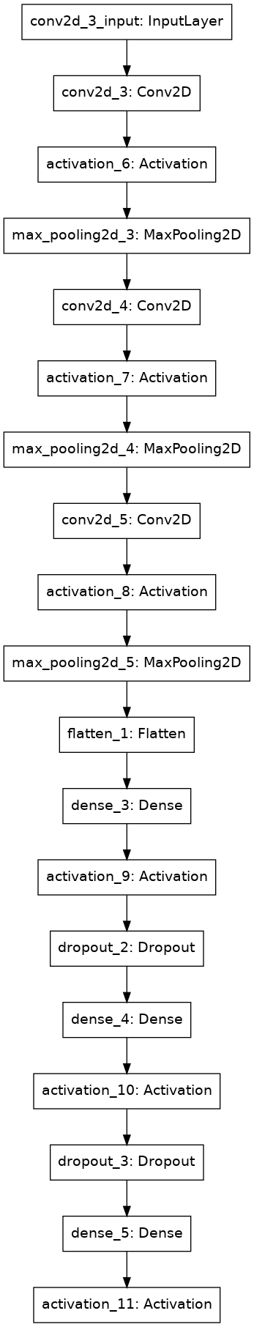

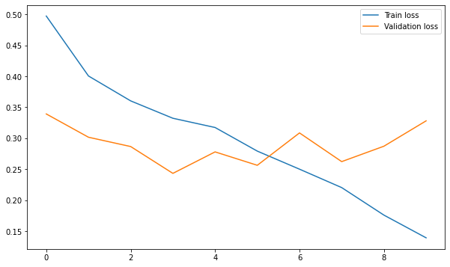

Fig 2.

The other part of the study deals with softwares to detect Air Quality Index and Water Potability.

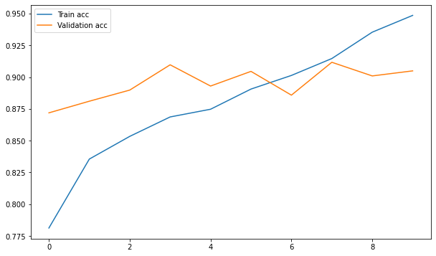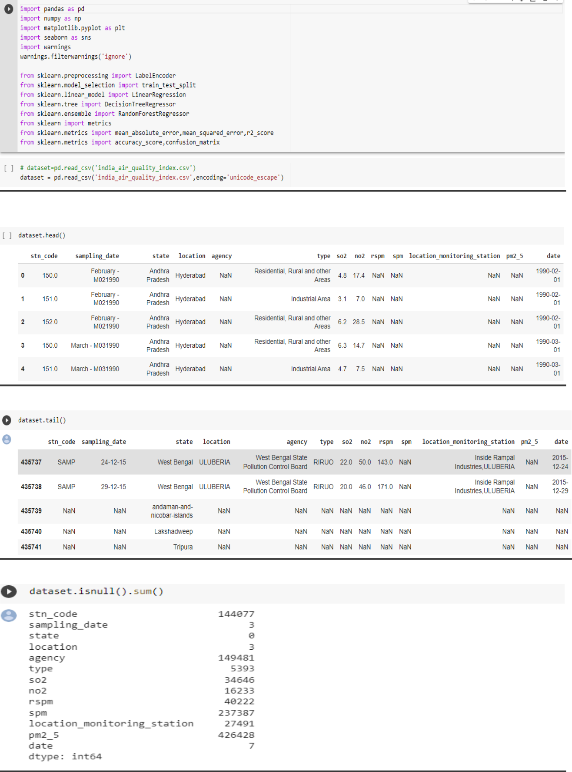

Fig 3 : the first few rows of the data set

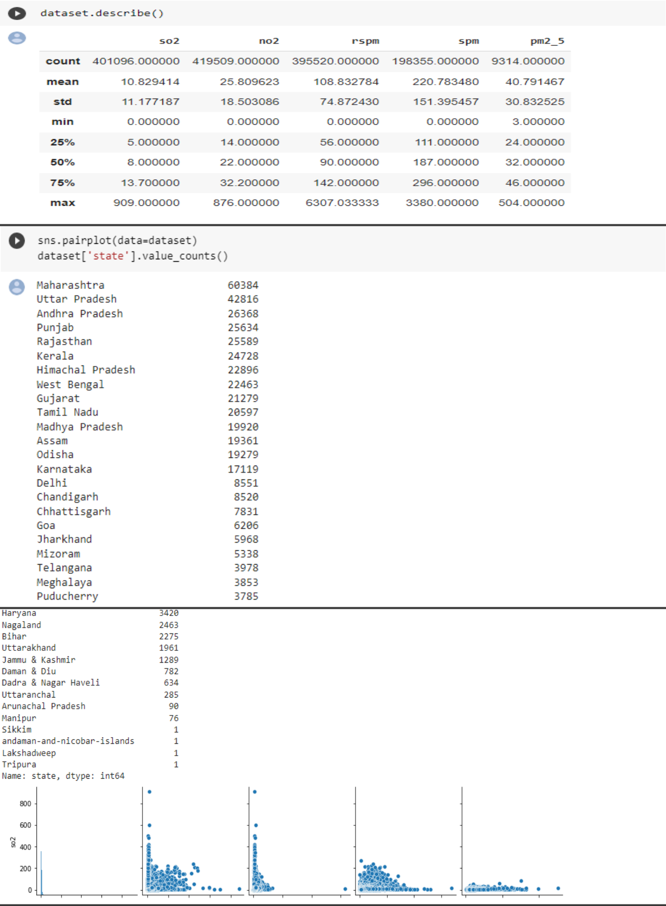

Fig 4 : The description of the dataset using pairplots

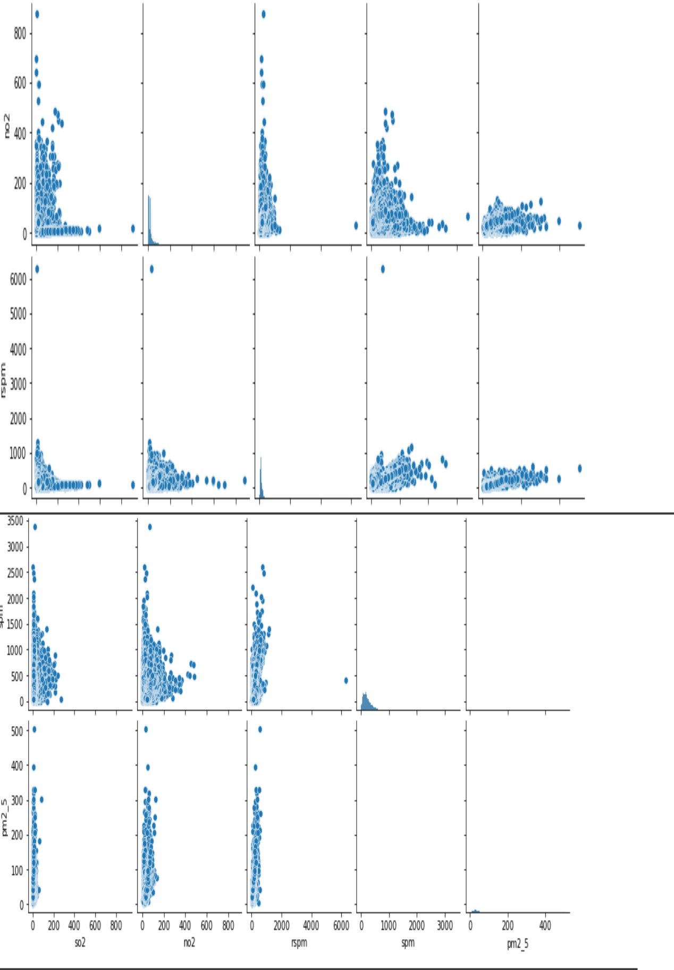

Fig. 5 : The pairplots of different coloumns in the data set

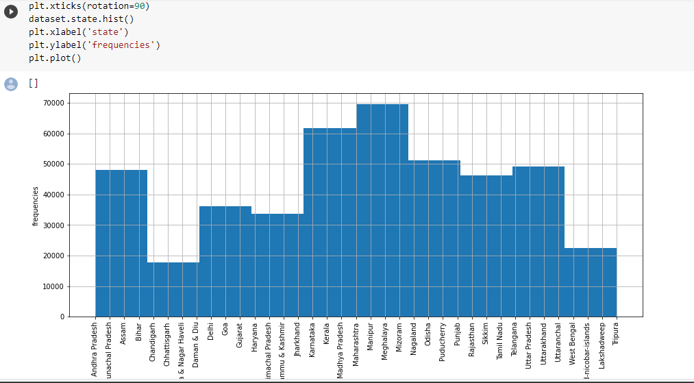

Fig 6. : A histogram where the X-axis represents the different states and the Y-axis represents the frequencies.

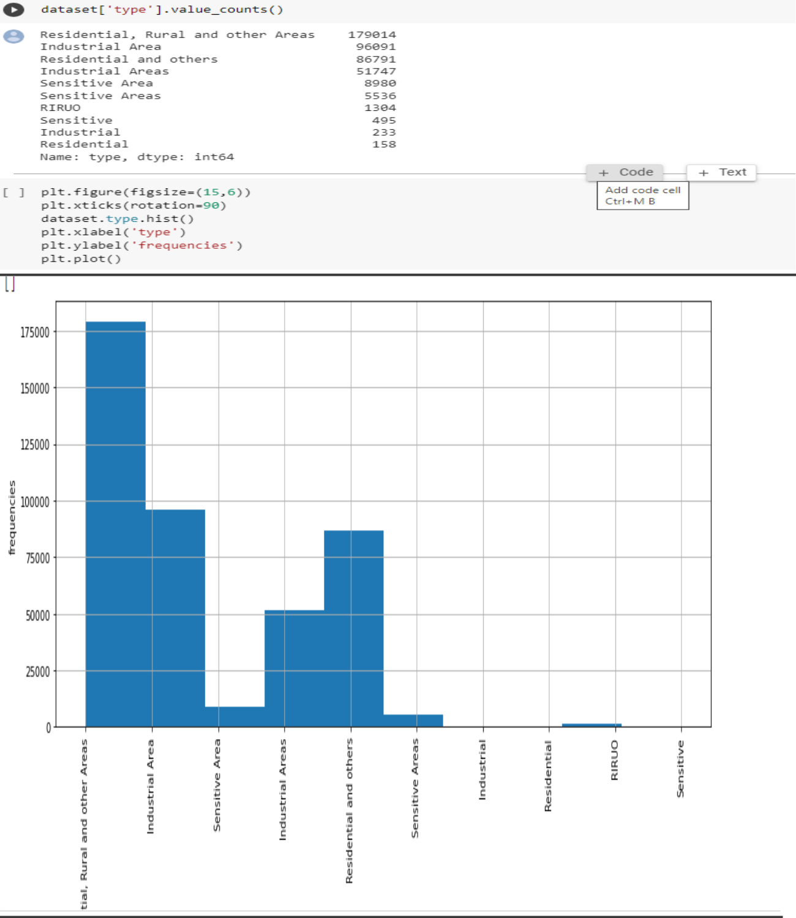

Fig. 7 : Histogram where X-axis represents the different sectors and the Y-axis represents the frequencies

## 

Fig. 8 : Bar Graph of the data set

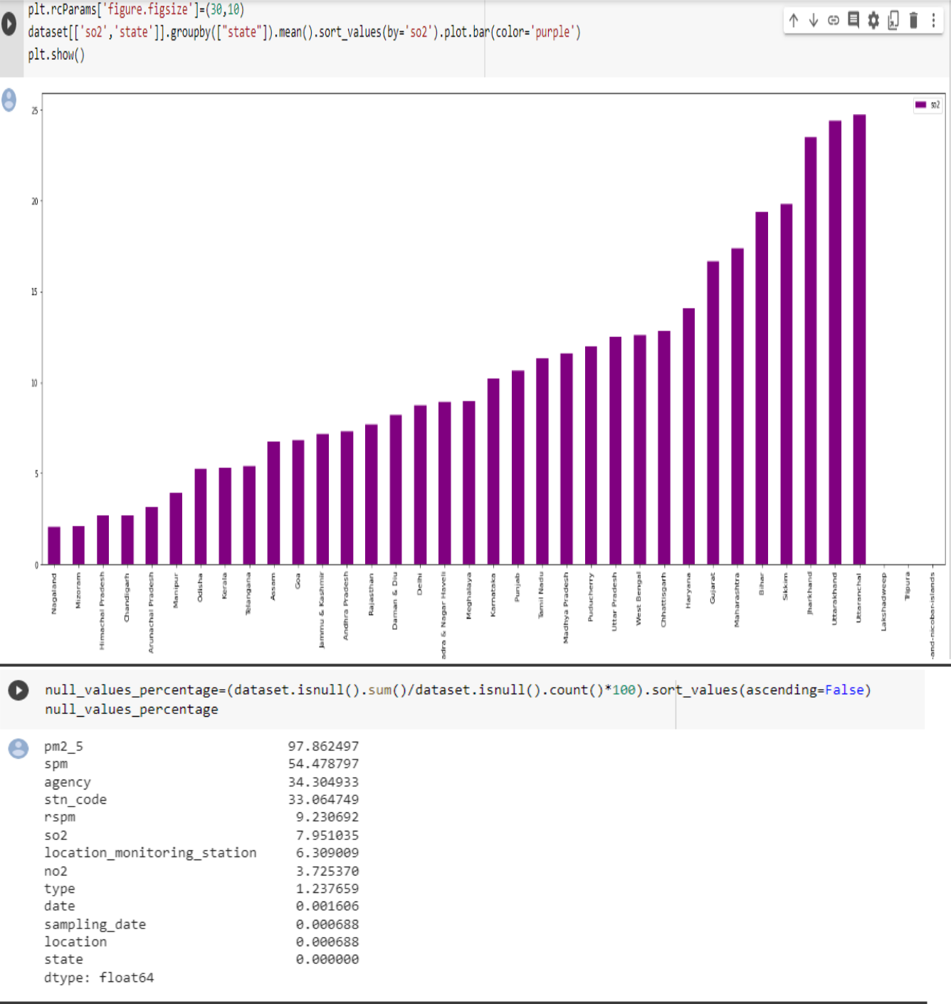

Fig 9 : Bar Graph of SO2 concentration in different state

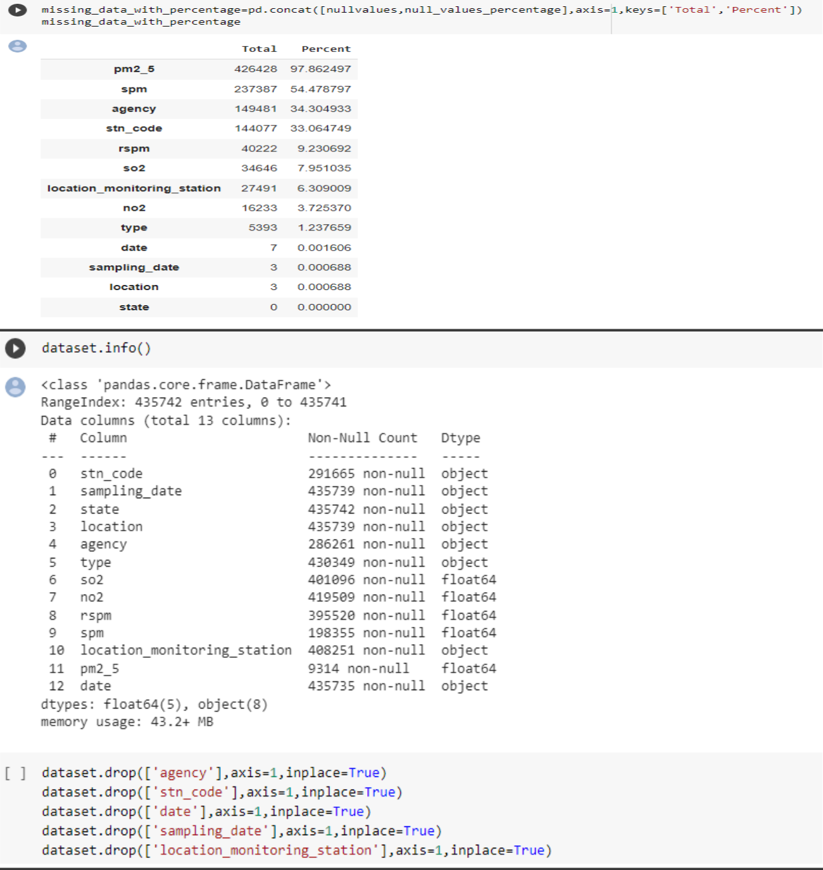

Fig. 10 : Shows the missing data in the rows

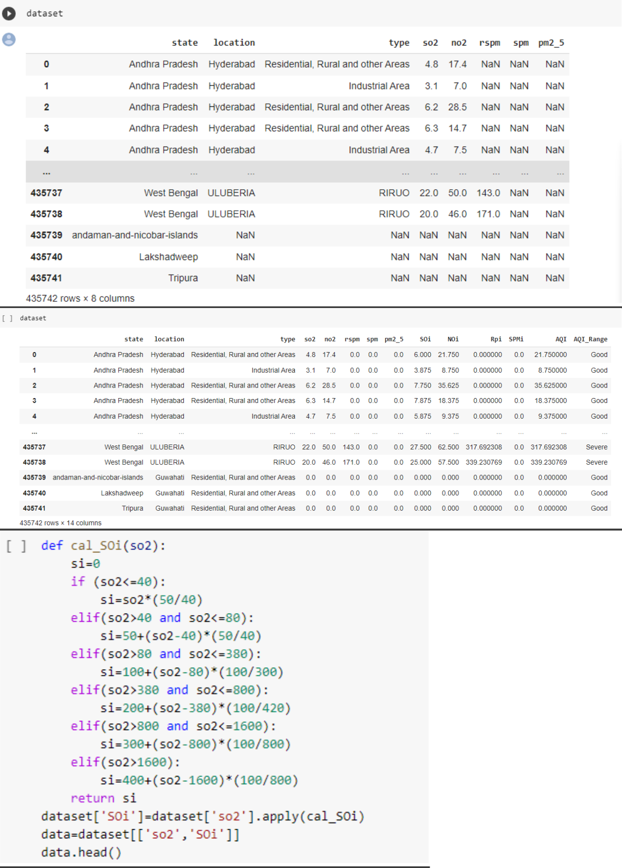 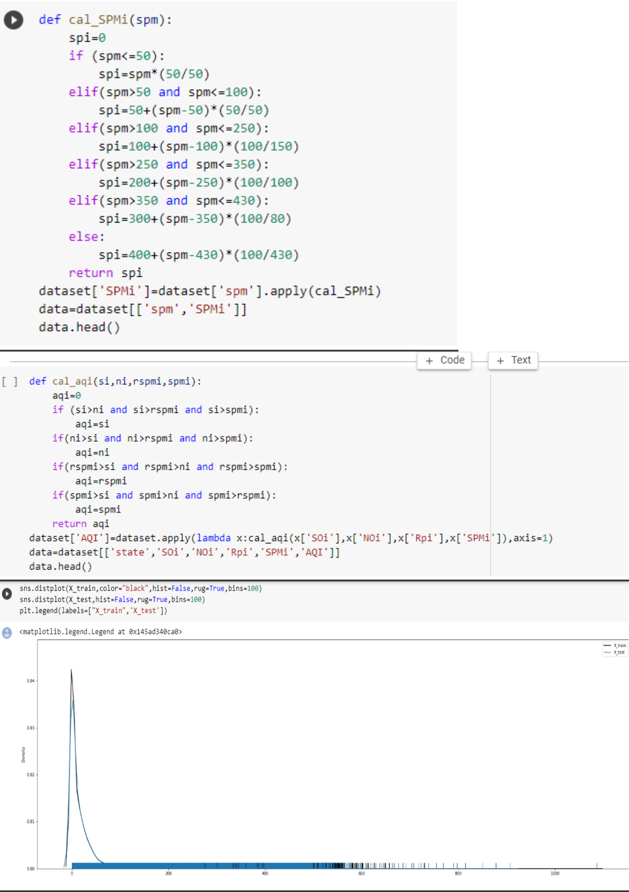

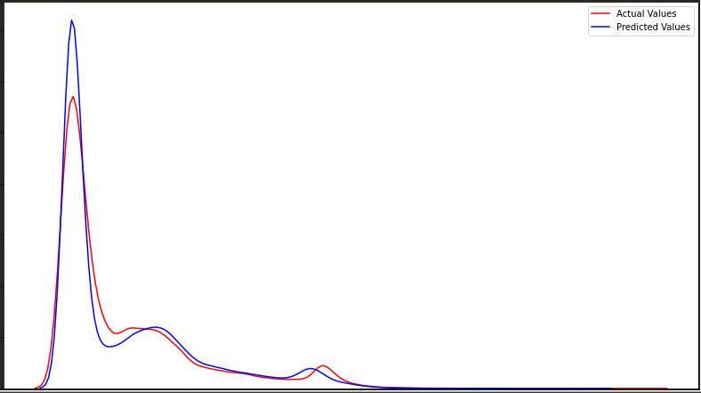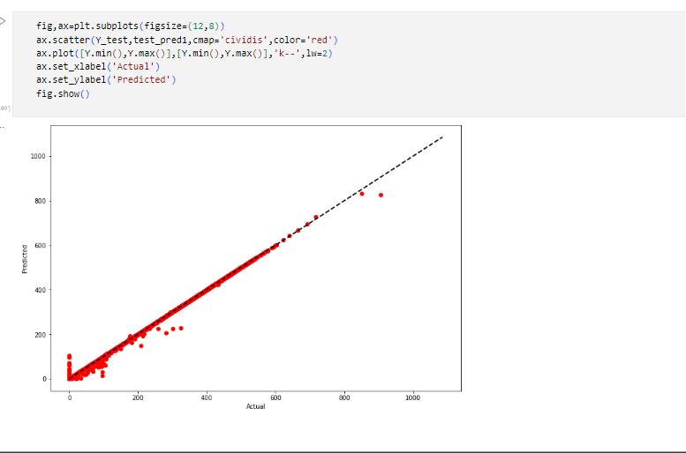

Fig 11 : Using the training data set to test the model

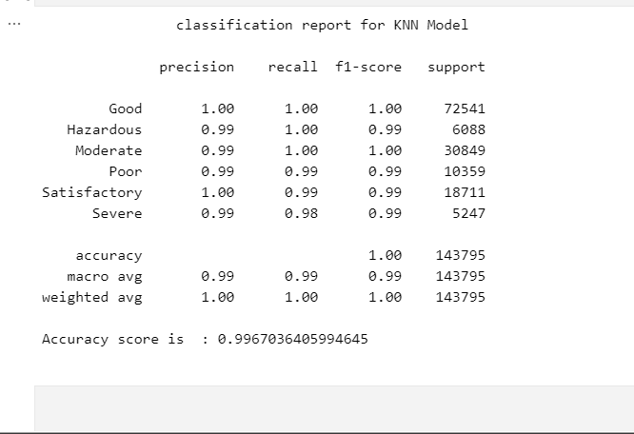

Fig 12 : KNN model is overfitted

WATER POTABILITY PREDICTION

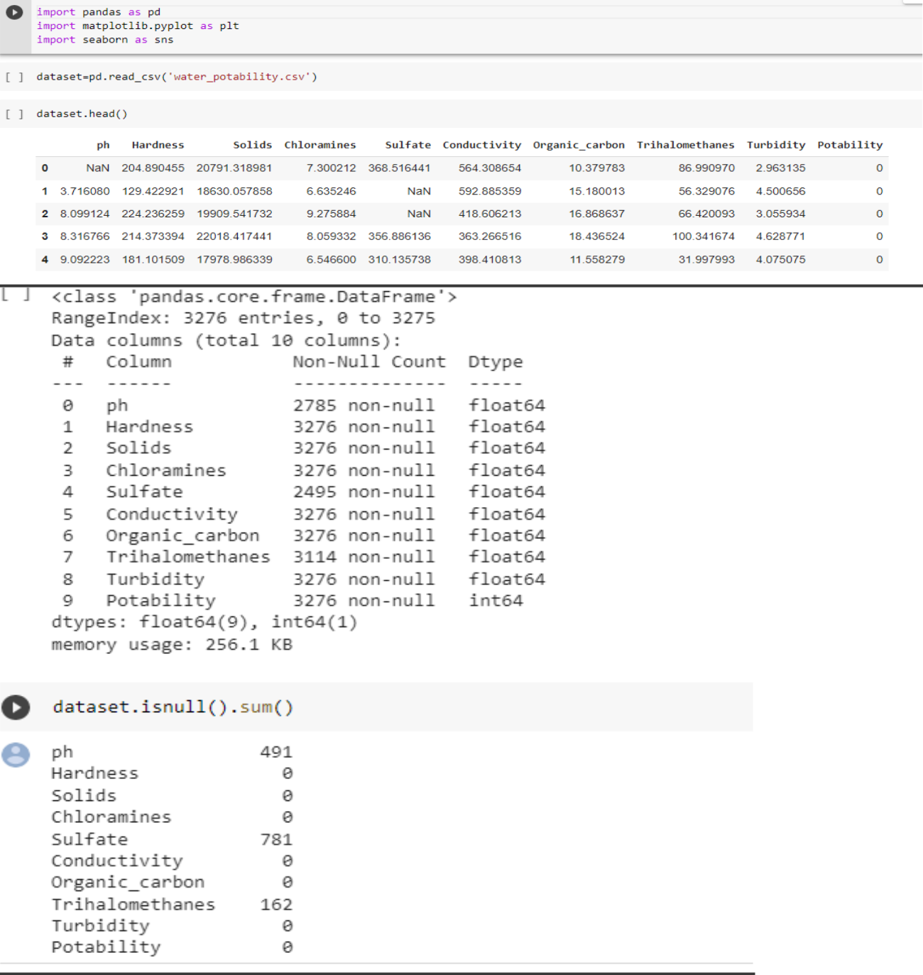

Fig 13 : The first few rows of the data set

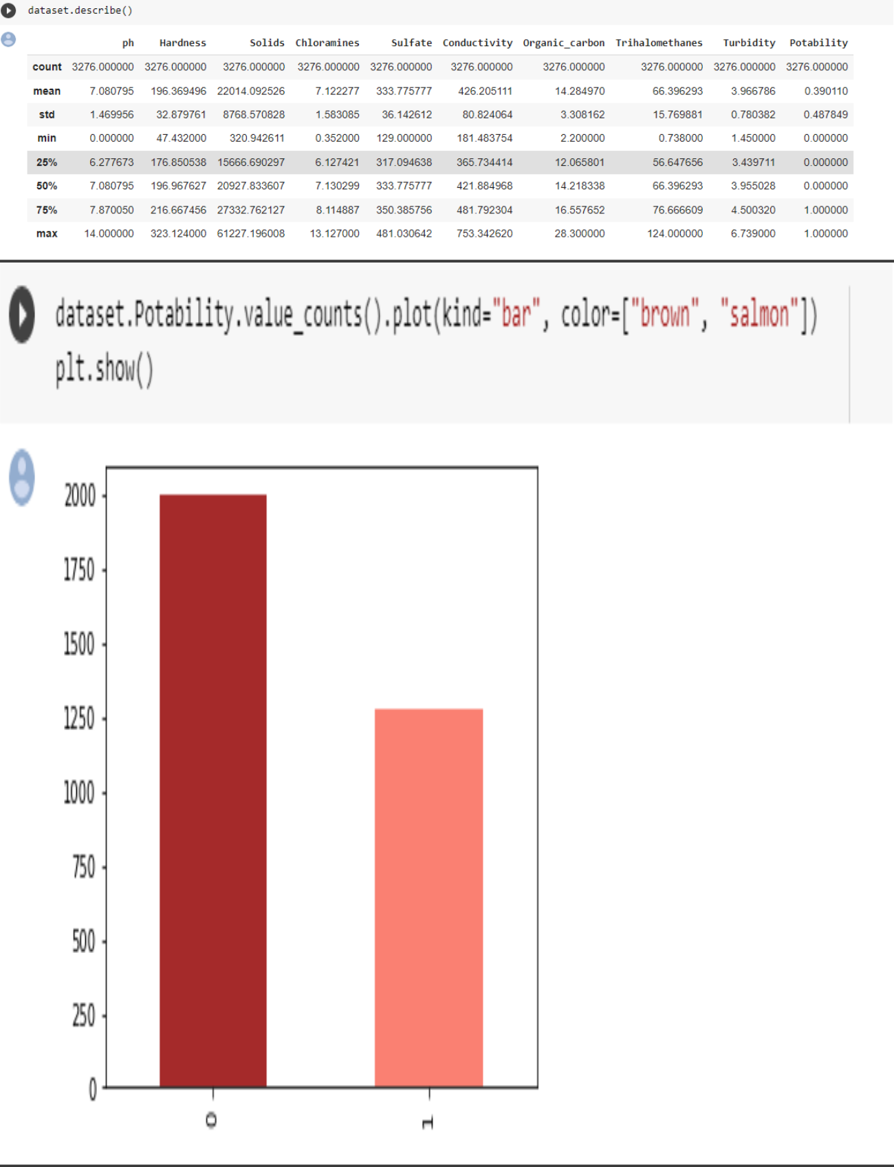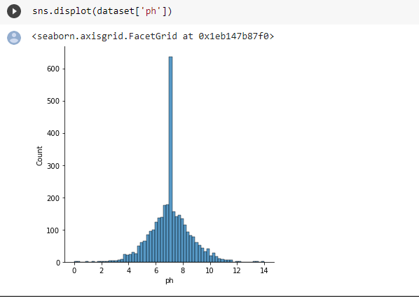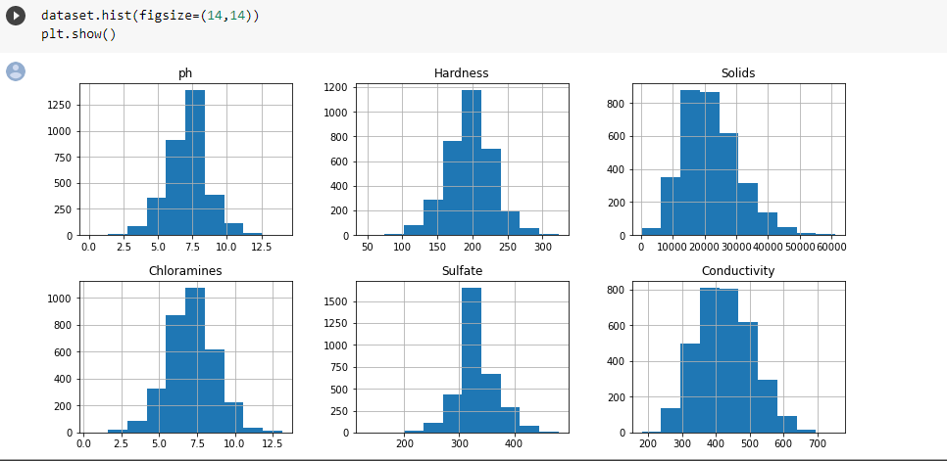  
Fig 14 : Histogram of the frequencies of the different coloumns of the data set  
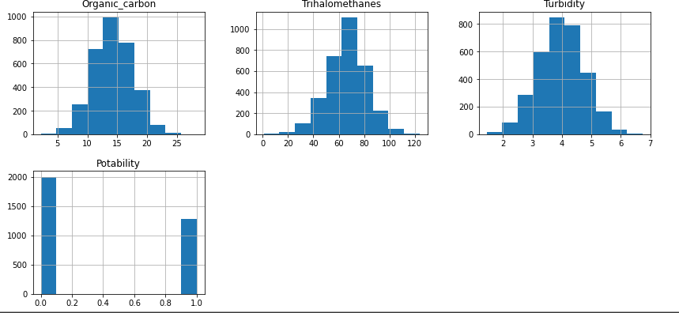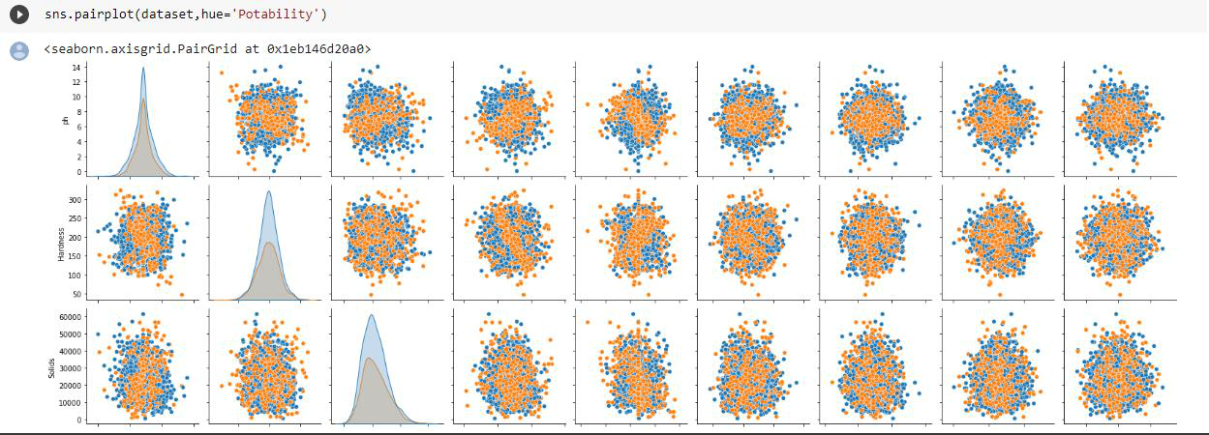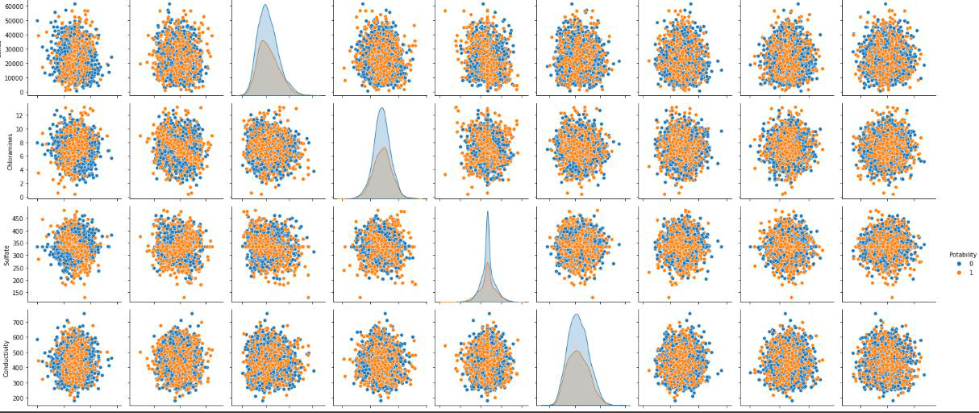

Fig 15 : pairplot of the different coloumns of the dataset

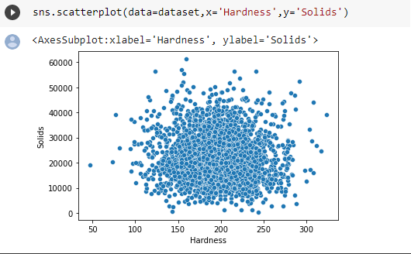  
Fig 16 : Scatterplot of the different hardness of the water

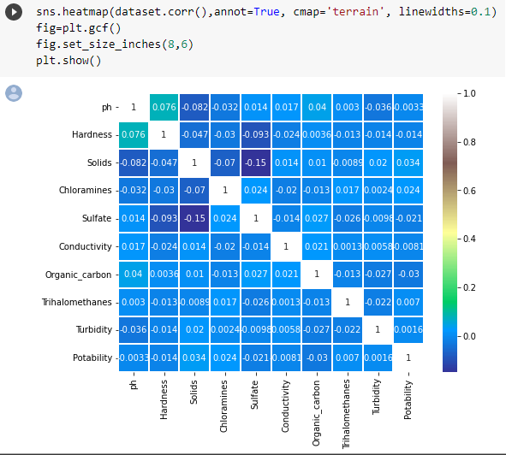  
  
Fig 17: heatmap of the different coloumns of the dataset.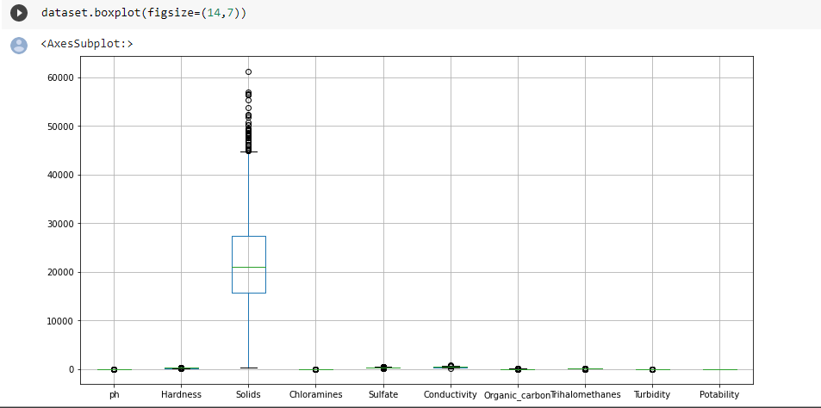  
Fig 19 : Boxplot of the coloumns of the dataset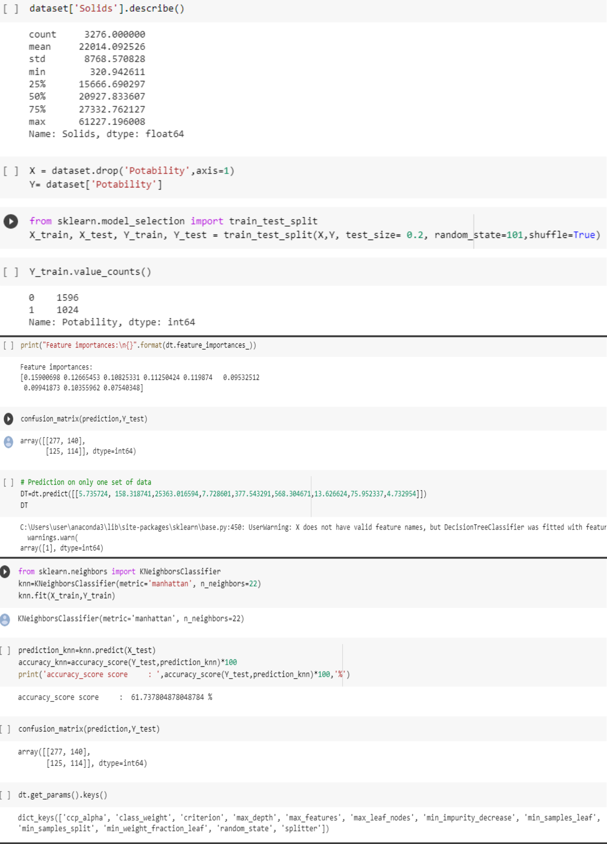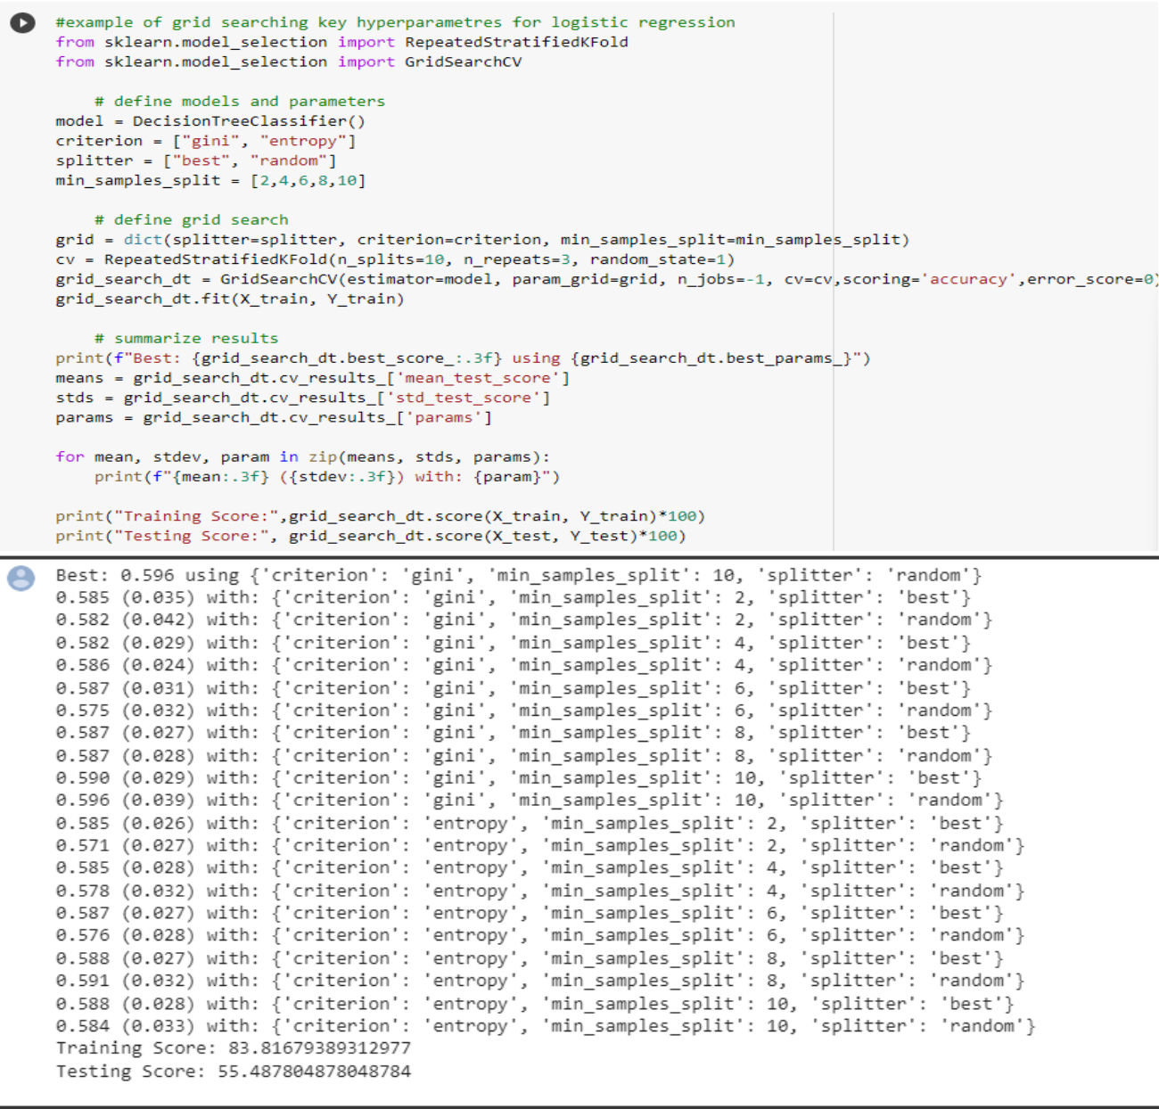  
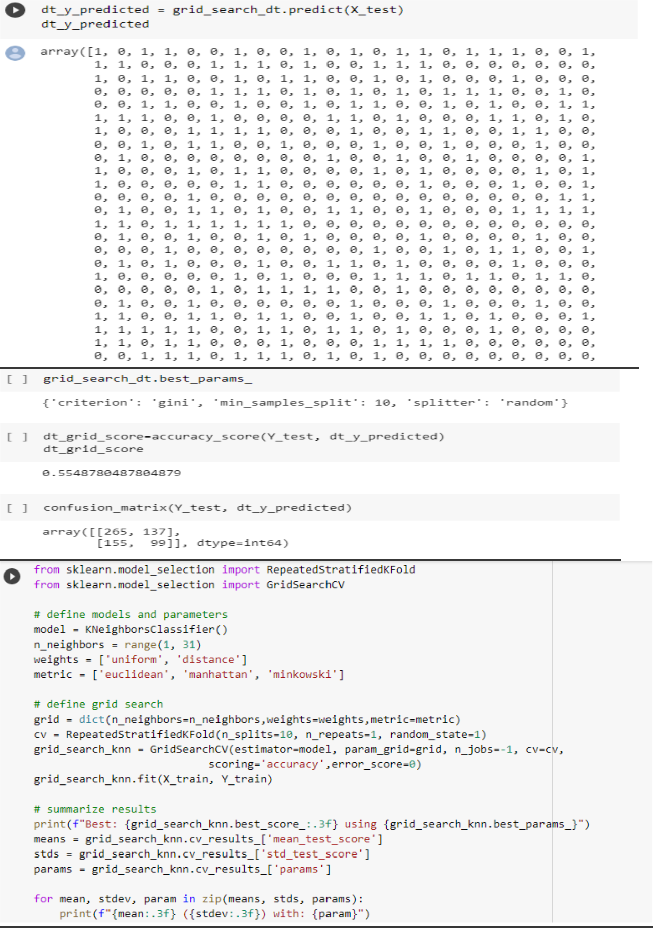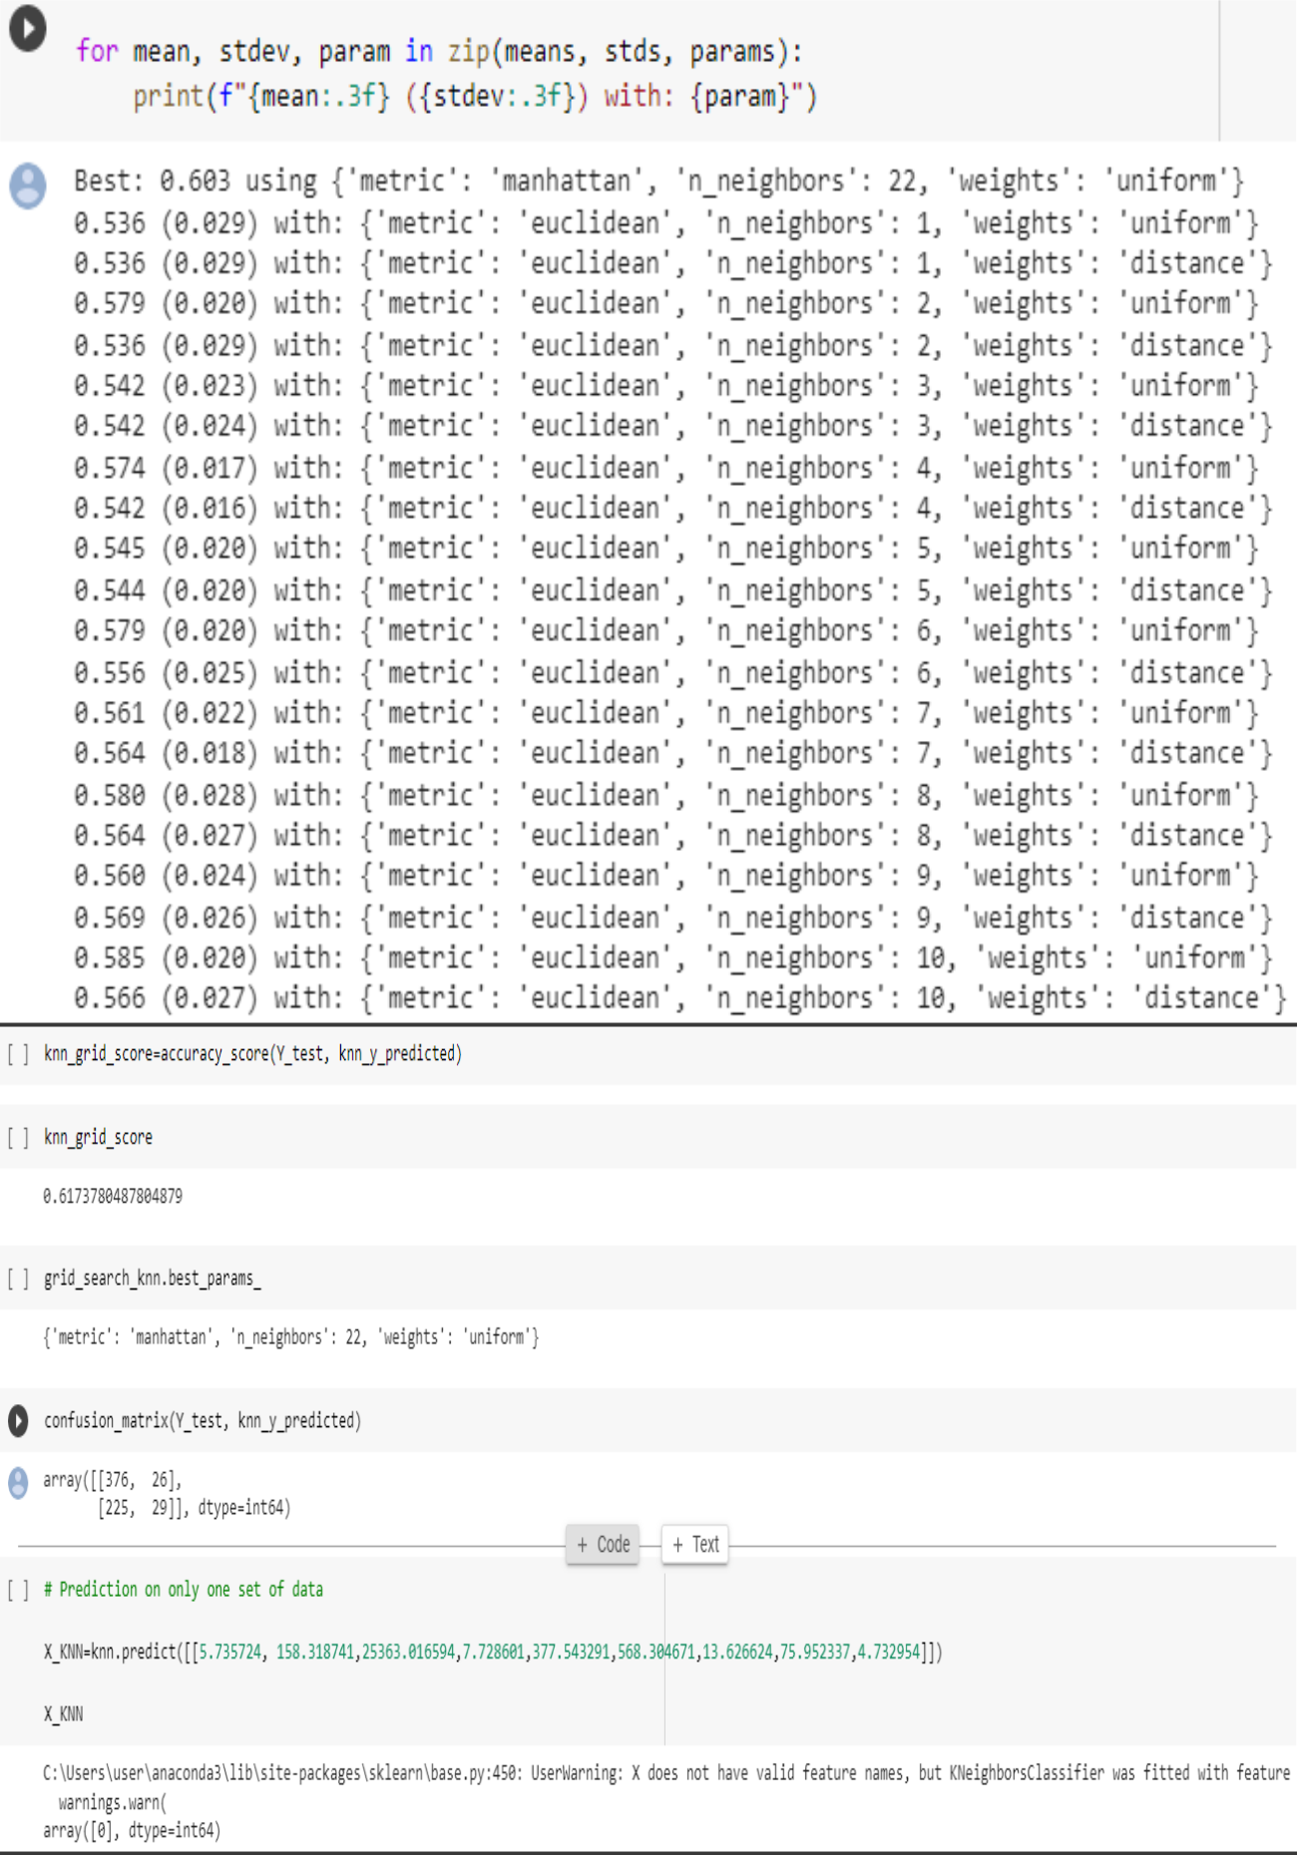Fig.20 : KNN model is 61% accurate

### **IX. Conclusion**

## A. Recap of the importance of AI in transforming waste management

AI has the potential to transform waste management practices by providing new solutions to address the global waste management crisis. By leveraging data analysis, machine learning, robotics, and other technologies, AI can improve the efficiency, sustainability, and cost-effectiveness of waste management practices.

Through the analysis of large amounts of data, AI-based waste management solutions can optimize waste collection and transportation, reduce reliance on landfills, increase recycling rates, and reduce greenhouse gas emissions. AI-based solutions also provide opportunities for innovation, collaboration, and public engagement, promoting awareness and education on the importance of proper waste management practices.

However, implementing AI-based waste management solutions also comes with challenges, including cost, data quality, technical expertise, and privacy and security concerns. Therefore, future research should focus on addressing these challenges and developing more effective and sustainable waste management practices. Overall, AI has the potential to revolutionize waste management practices, creating a more sustainable and efficient future for waste management.

B. Key findings of the study

There have been several studies and research on the use of AI in waste management, and the key findings suggest that AI has a significant potential to improve the efficiency and sustainability of waste management processes. Here are some of the main conclusions from these studies:

1. AI can help optimize waste collection and transportation, resulting in reduced costs and improved efficiency.
2. AI-powered sorting systems can increase recycling rates and reduce the amount of waste sent to landfills.
3. Predictive maintenance using AI can help prevent equipment failures, reduce downtime, and lower repair costs.
4. AI can help improve waste-to-energy processes, making them more efficient and environmentally friendly.
5. AI can help identify opportunities for waste reduction, reuse, and recycling, leading to a more circular economy.

In conclusion, the use of AI in waste management has great potential to transform the industry and lead to a more sustainable and efficient future. As technology continues to advance, we can expect to see more innovative and effective solutions being developed to address the challenges of waste management.

C. Implications for waste management practitioners and policy makers

AI-based waste management solutions have significant implications for waste management practitioners and policy makers. Here are some of the key implications:

1. Adoption of new technologies: Waste management practitioners and policy makers need to be willing to adopt and implement new technologies, such as sensors, machine learning, and robotics, to improve waste management practices. This requires investing in the necessary infrastructure, data analysis, and technical expertise.
2. Collaboration and innovation: Collaboration between waste management practitioners, academia, and industry is essential for the development of new AI-based waste management solutions. Policy makers can encourage innovation by providing funding and support for research and development.
3. Environmental and social benefits: AI-based waste management solutions can provide significant environmental and social benefits, including reduced greenhouse gas emissions, improved recycling rates, and increased public engagement in sustainability efforts. Policy makers can promote these benefits by implementing policies that support sustainable waste management practices.
4. Privacy and security: Policy makers need to ensure that privacy and security concerns are addressed when implementing AI-based waste management solutions. This requires developing and enforcing policies and regulations that protect personal information and data.
5. Public engagement and education: Waste management practitioners and policy makers need to engage the public and promote education on the importance of proper waste management practices. This can encourage the adoption of new technologies and practices, and promote a more sustainable and efficient future for waste management.

Overall, the implications of AI-based waste management solutions require waste management practitioners and policy makers to be willing to adopt new technologies, collaborate, innovate, and promote sustainable practices. By doing so, we can create a more sustainable and efficient future for waste management.

D. Call for action towards more sustainable waste management practices-

There is an urgent need for action towards more sustainable waste management practices, and AI-based solutions have the potential to play a significant role in achieving this goal. Here are some actions that can be taken towards more sustainable waste management practices:

1. Reduce waste generation: Waste reduction should be a top priority, and policy makers and waste management practitioners should encourage waste reduction practices, such as reusing and recycling.
2. Adopt AI-based waste management solutions: Waste management practitioners and policy makers should adopt AI-based waste management solutions to improve efficiency and sustainability. This can include the use of sensors, machine learning, and robotics to optimize waste collection, transportation, and recycling.
3. Promote public education and engagement: The public should be educated on the importance of proper waste management practices, including the benefits of recycling and waste reduction. Waste management practitioners and policy makers can promote public education and engagement through outreach programs, community events, and social media.
4. Implement policies and regulations: Policy makers should implement policies and regulations that promote sustainable waste management practices, such as waste reduction targets, extended producer responsibility, and incentives for recycling.
5. Collaborate and innovate: Waste management practitioners, academia, and industry should collaborate and innovate to develop new and more effective waste management solutions. This can include the development of new sensors, machine learning algorithms, and robotics technologies.

By taking these actions, we can move towards a more sustainable future for waste management. It is crucial that we act now to address the global waste management crisis and create a more sustainable and efficient future for waste management. AI has the potential to make waste management more efficient, sustainable, and cost-effective. As technology continues to evolve, we can expect to see more innovative AI solutions in the waste management industries

**X. References**

1. *modelling and prediction of water quality by using artificial intelligence.* **al-adhaileh, hmoud.**

https://doi.org/10.3390/su13084259

2. Jatin. (2021, October 2). Water Quality Prediction using Machine Learning. *Blogger*. https://www.datascience2000.in/2021/10/water-quality-prediction-using-machine.html

3. Maltare, N. N., & Vahora, S. (2023). Air Quality Index prediction using machine learning for Ahmedabad city. *Digital Chemical Engineering*, *7*, 100093. https://doi.org/10.1016/j.dche.2023.100093

4. Mathur, M., Tawar, A., & Verma, I. (2023, March 28). *A smart city air pollution prediction system using machine learning*. Unknown. https://www.researchgate.net/publication/369631111_A_Smart_City_Air_Pollution_Prediction_System_Using_Machine_Learning

5. Patel, J., Amipara, C., Ahanger, T. A., Ladhva, K., Gupta, R. K., Alsaab, H. O., Althobaiti, Y. S., & Ratna, R. (2022). A machine learning-based water potability prediction model by using synthetic minority oversampling technique and explainable AI. *Computational Intelligence and Neuroscience*, *2022*. https://doi.org/https://doi.org/10.1155/2022/9283293

*6. Prediction of air quality index using supervised machine learning*. (n.d.). https://www.ijraset.com/research-paper/prediction-of-air-quality-index-using-supervised-machine-learning

7. Srinilta, C., & Kanharattanachai, S. (n.d.). Municipal solid waste segregation with CNN. *2019 5th International Conference on Engineering, Applied Sciences and Technology (ICEAST)*.

8. Varudandi, S., Mehta, R., Mahetalia, J., Parmar, H., & Samdani, K. (n.d.). A Smart Waste Management and Segregation System that Uses Internet of Things, Machine Learning and Android Application. *2021 6th International Conference for Convergence in Technology (I2CT)*.

9. Wang, H. (2020, April 1). *Garbage recognition and classification system based on convolutional neural network VGG16*. Unknown. https://www.researchgate.net/publication/342647864_Garbage_Recognition_and_Classification_System_Based_on_Convolutional_Neural_Network_VGG16

10. Zhu, M., Wang, J., Yang, X., & Ye, L. (2022, July 1). *A review of the application of machine learning in water quality evaluation*. Unknown. https://www.researchgate.net/publication/361875031_A_review_of_the_application_of_machine_learning_in_water_quality_evaluation